UNITED STATES

SECURITIES AND EXCHANGE COMMISSION
WASHINGTON, D.C. 20549

FORM 6-K

REPORT OF FOREIGN PRIVATE ISSUER

PURSUANT TO RULE 13a-16 OR 15d-16 UNDER

THE SECURITIES EXCHANGE ACT OF 1934

For the month of June 2026

Commission File Number: 001-41115

GENENTA SCIENCE S.P.A.

(Translation of registrant’s name into English)

Via dell’Annunciata 31

20121 Milan, Italy

(Address of Principal Executive Offices)

Indicate by check mark whether the registrant files or will file annual reports under cover of Form 20-F or Form 40-F.

Form 20-F ☒ Form 40-F ☐

Indicate by check mark if the registrant is submitting the Form 6-K in paper as permitted by Regulation S-T Rule 101(b)(1): ☐

Indicate by check mark if the registrant is submitting the Form 6-K in paper as permitted by Regulation S-T Rule 101(b)(7): ☐

This report on Form 6-K, including Exhibits 10.1 and 10.2, is incorporated by reference into the registrant’s registration statement on Form S-8 (File No.

333-278392).

Other Events

Severance Agreement

On June 19, 2026, Genenta Science S.p.A. (the “Company”) entered into a Parachute Agreement with Pierluigi Paracchi (the “Severance Agreement”), the Company’s Chief Executive Officer and General Manager, in connection with his existing employment agreement with the Company.

Pursuant to the Severance Agreement, upon the occurrence of certain qualifying termination events, as set forth therein, Mr. Paracchi will be entitled to receive a lump-sum severance payment equal to twelve months of his last gross remuneration calculated pursuant to applicable Italian law, plus an amount equal to his target annual bonus opportunity under his employment agreement, up to 40% of his annual gross remuneration

Amendment to Non-Compete Covenant

On June 19, 2026, the Company also entered into an amendment to the non-compete covenant set out in Clause 11 of Mr. Paracchi’s employment agreement. The amendment clarifies and narrows the scope of activities deemed competitive for purposes of the non-compete covenant by limiting such scope to certain activities in the pharmaceutical, biotechnology, molecular and cellular medicine, genetics, and diagnostics sectors, as set forth therein.

Forward-Looking Statements

This Current Report on Form 6-K (this “Report”) contains forward-looking statements within the meaning of applicable securities laws. These statements are based on current expectations and assumptions and are subject to risks and uncertainties that could cause actual results to differ materially from those expressed or implied by such statements.

The foregoing descriptions of the Severance Agreement and the amendment to the non-compete covenant do not purport to be complete and are qualified in their entirety by reference to the full text of such agreements, copies of which are filed as Exhibit 10.1 and 10.2, respectively, to this Report and are incorporated by reference herein.

SUBMITTED HEREWITH

Attached to this Report for the month of June 2026, and incorporated by reference herein, is:

Exhibits.
Exhibit No. |  | Description
10.1 |  | Parachute Agreement dated June 19, 2026, between Genenta Science S.p.A. and Pierluigi Paracchi.
10.2 |  | Amendment to Non-Compete Covenant dated June 19, 2026, between Genenta Science S.p.A. and Pierluigi Paracchi.

SIGNATURES

Pursuant to the requirements of the Securities Exchange Act of 1934, the registrant has duly caused this report to be signed on its behalf by the undersigned hereunto duly authorized.

GENENTA SCIENCE S.P.A.

By: /s/ Pierluigi Paracchi

Name: Pierluigi Paracchi

Title: Chief Executive Officer

Dated: June 24, 2026

Exhibit 10.1
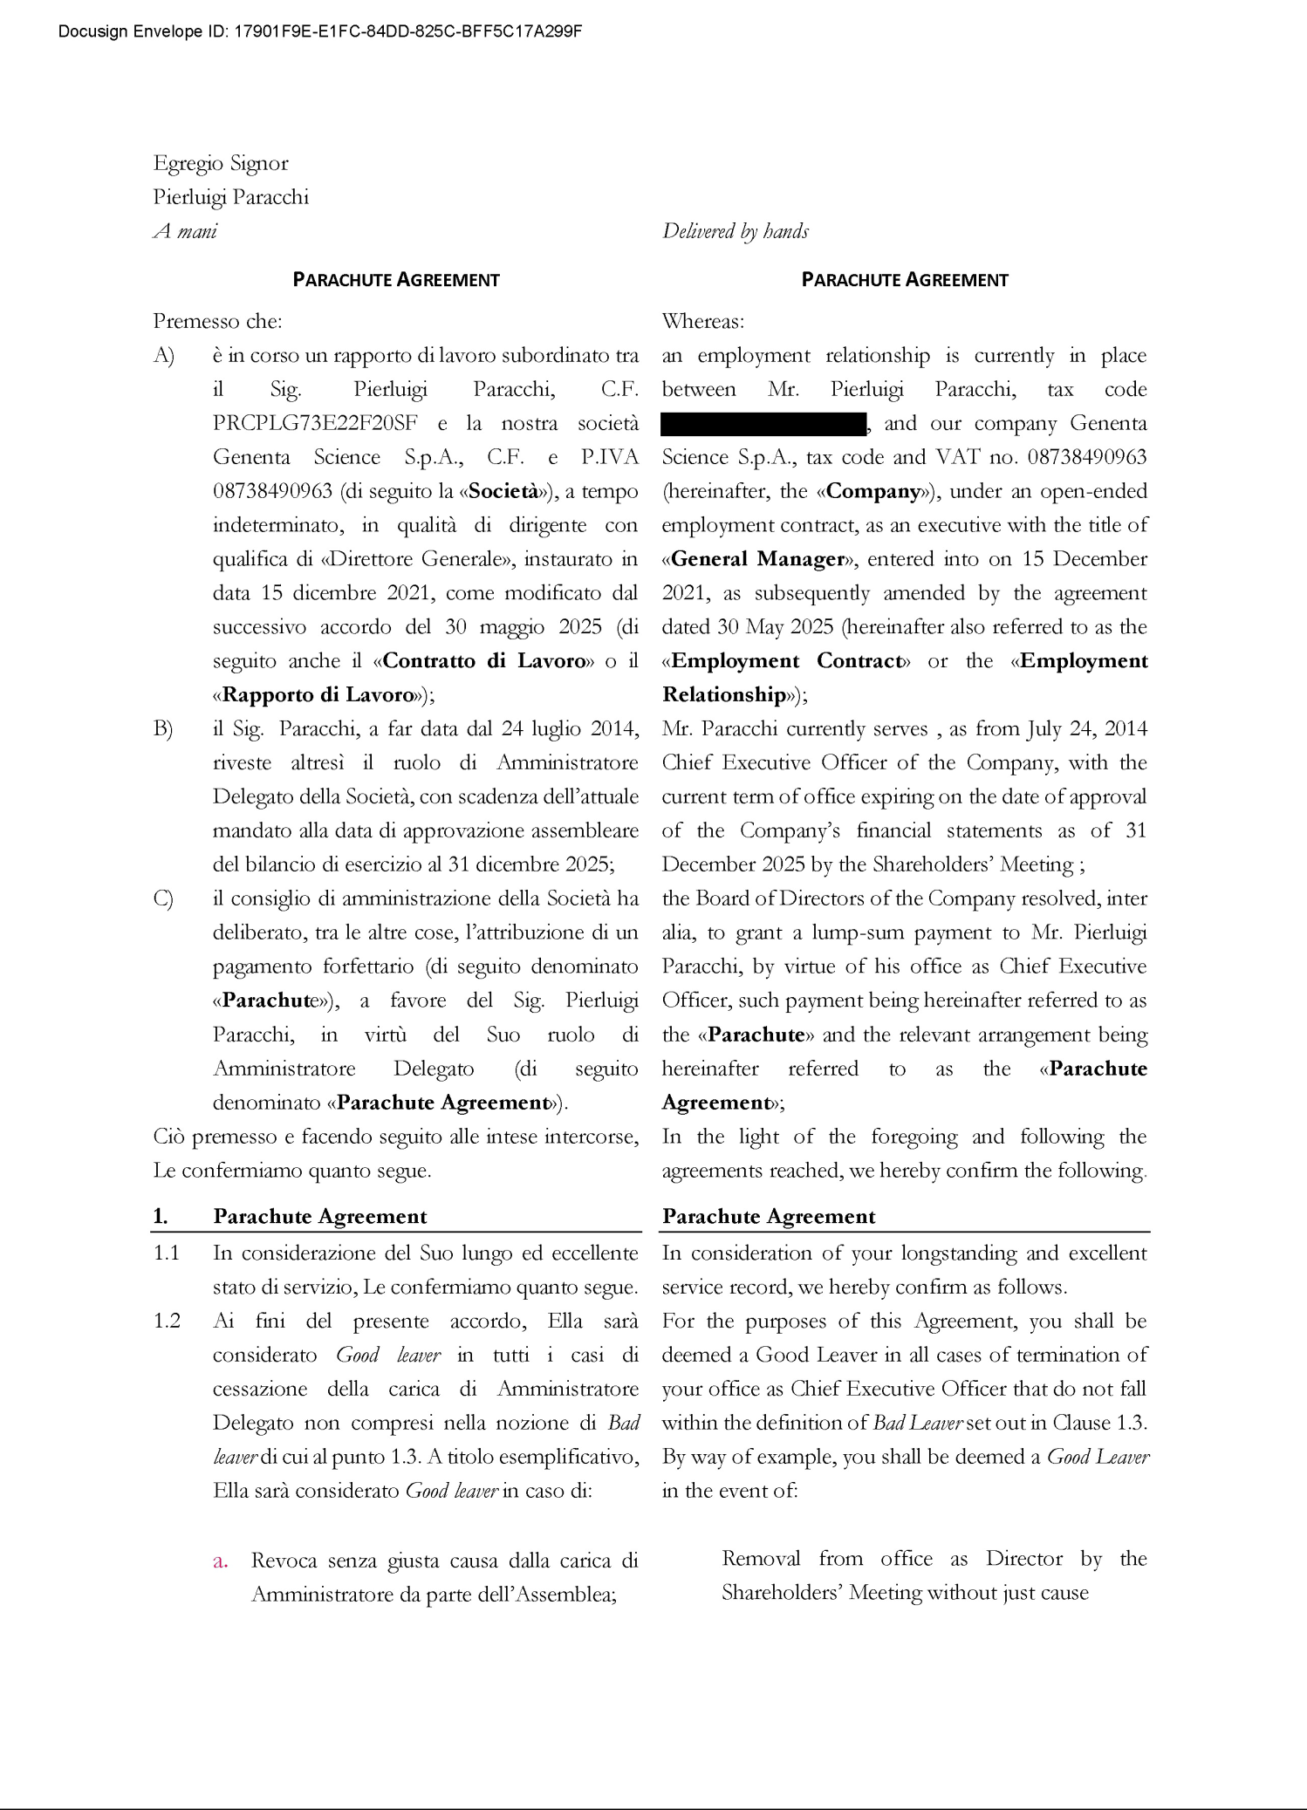

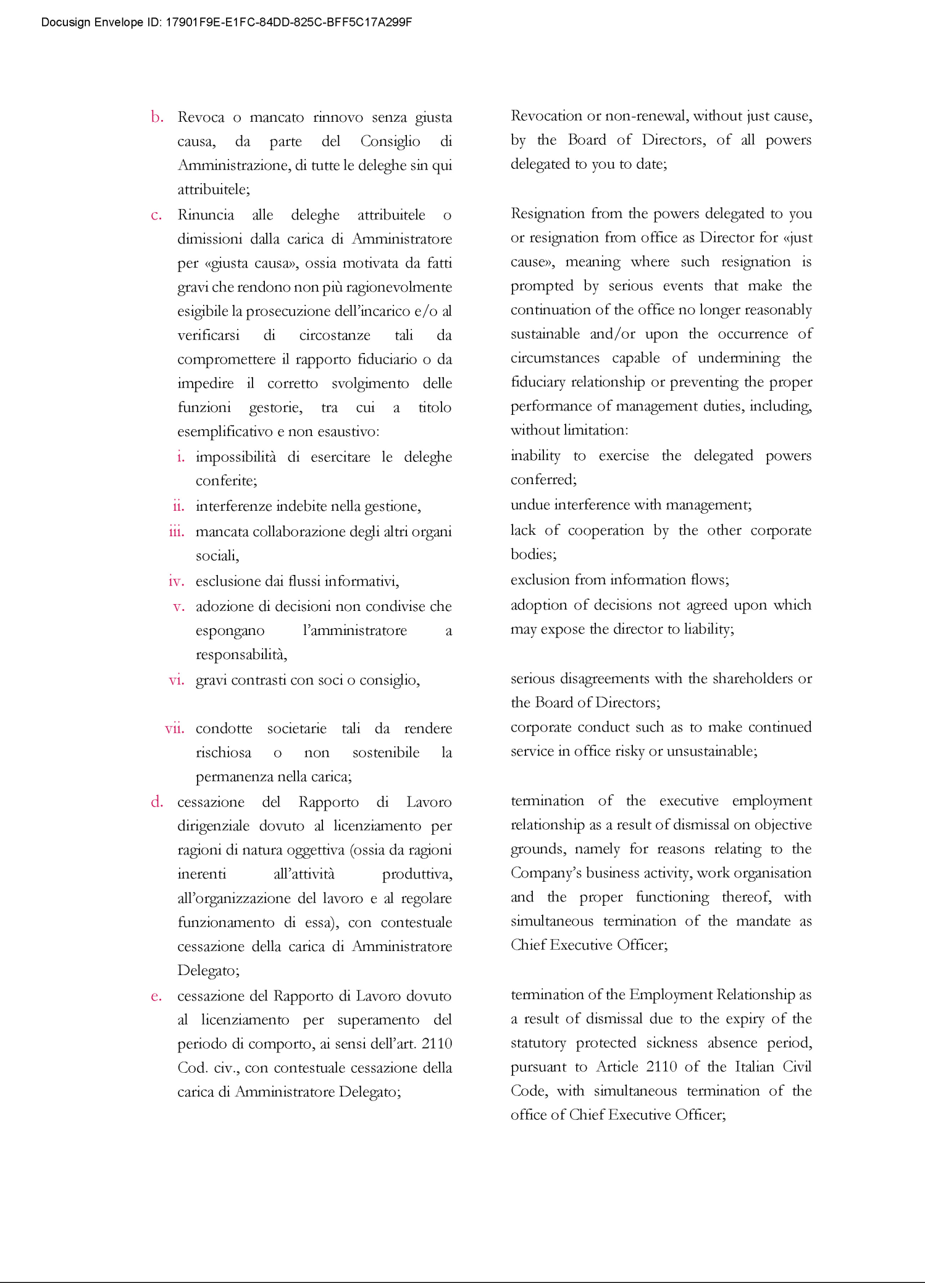

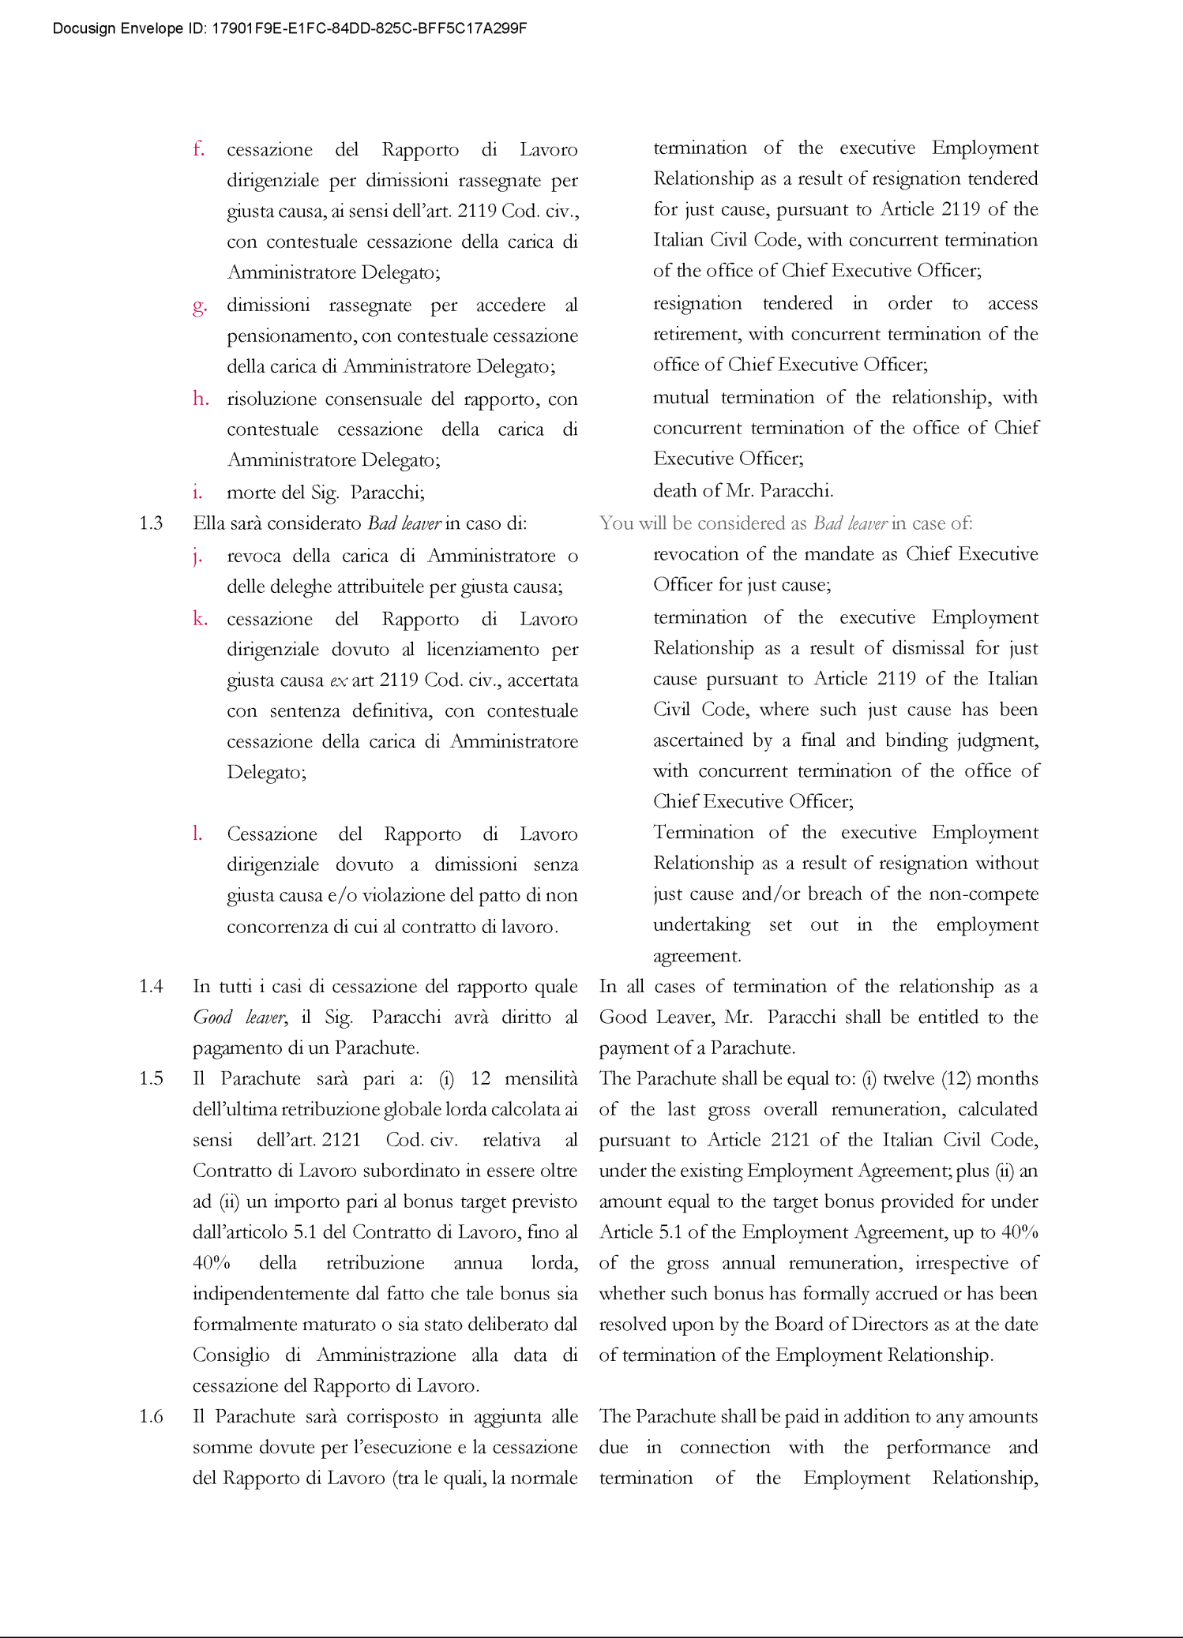

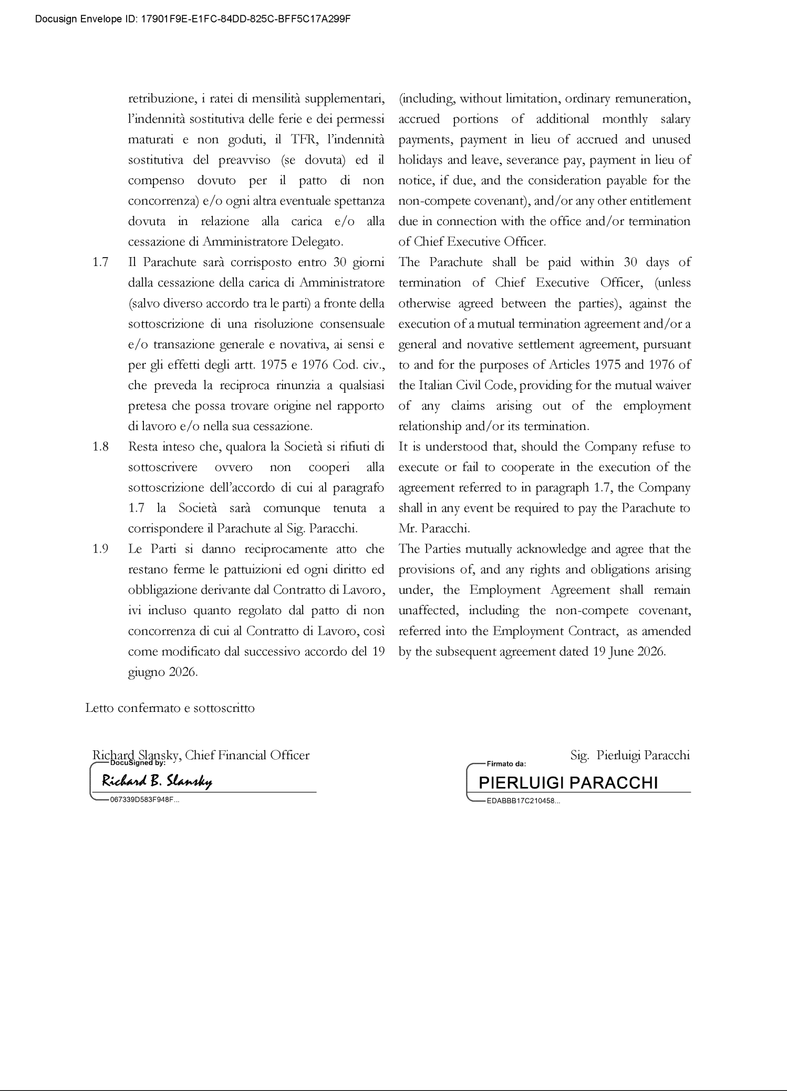

Exhibit 10.2


