UNITED STATES

SECURITIES AND EXCHANGE COMMISSION
Washington, D.C. 20549

FORM 6-K

Report of Foreign Private Issuer

Pursuant to Rule 13a-16 or 15d-16

Under the Securities Exchange Act of 1934

For the month of October 2023

Commission File Number: 001-41115

GENENTA SCIENCE S.P.A.

(Translation of Registrant’s Name into English)

Via Olgettina No. 58

20132 Milan, Italy

(Address of principal executive office)

Indicate by check mark whether the registrant files or will file annual reports under cover of Form 20-F or Form 40-F:

Form 20-F ☒ Form 40-F ☐

Indicate by check mark if the registrant is submitting the Form 6-K in paper as permitted by Regulation S-T Rule 101(b)(1): ☐

Indicate by check mark if the registrant is submitting the Form 6-K in paper as permitted by Regulation S-T Rule 101(b)(7): ☐ This report on Form 6-K is incorporated by reference into the registrant’s registration statement on Form F-3 (File No. 333-271901).

Genenta Science S.p.A. Reports Financial Results for the Six Months Ended June 30, 2023

Genenta Science S.p.A. (“Genenta”) is furnishing this report on Form 6-K to provide its unaudited consolidated financial statements as of June 30, 2023, and for the six months ended June 30, 2023, and June 30, 2022, and to provide its Management’s Discussion and Analysis of Financial Condition and Results of Operations with respect to such financial statements.

The unaudited consolidated financial statements as of June 30, 2023, and for the six months ended June 30, 2023, and June 30, 2022, are attached to this Form 6-K as Exhibit 99.1. Management’s Discussion and Analysis of Financial Condition and Results of Operations is attached to this Form 6-K as Exhibit 99.2.

As described in more detail in Note 14, Subsequent events to the financial statements attached as Exhibit 99.1 hereto, (i) on August 1, 2023, Genenta entered into a Sponsored Research Agreement (the “CP1 SRA”) with Ospedale San Raffaele S.r.l. (“OSR”) to perform certain feasibility studies contemplated under the Company’s amended and restated license agreement with OSR (the “ARLA”), and (ii) on September 28, 2023, Genenta and OSR entered into a related amendment to the ARLA.

The descriptions of the CP1 SRA and the amendment to the ARLA contained in this Form 6-K and in Exhibits 99.1 and 99.2 hereto do not purport to be complete and are qualified in their entirety by reference to the complete text thereof, copies of which are filed as exhibits 10.1 and 10.2, respectively, to this Form 6-K.

EXHIBIT INDEX

Exhibit Title

10.1† Sponsored Research Agreement between Genenta Science S.p.A. and Ospedale San Raffaele S.r.l. dated August 1, 2023

10.2† Amendment to Amended and Restated License Agreement between Genenta Science S.p.A. and Ospedale San Raffaele S.r.l. dated September

28, 2023

99.1 Unaudited Consolidated Financial Statements as of June 30, 2023, and for the six months ended June 30, 2023, and June 30, 2022.

99.2 Management’s Discussion and Analysis of Financial Condition and Results of Operations.

- The following materials from Genenta’s Report on Form 6-K for the six months ended June 30, 2023, formatted in Inline XBRL (eXtensible Business Reporting Language): (i) the Consolidated Balance Sheets, (ii) the Consolidated Statements of Operations and Comprehensive Loss,

  - the Consolidated Statements of Changes in Shareholders’ Equity, (iv) the Consolidated Statements of Cash Flows, and (v) Notes to the Consolidated Financial Statements.

    - Portions of this exhibit (indicated with markouts) have been redacted in accordance with Item 601(b)(10)(iv).

SIGNATURES

Pursuant to the requirements of the Securities Exchange Act of 1934, the registrant has duly caused this report to be signed on its behalf by the undersigned, thereunto duly authorized.

GENENTA SCIENCE S.P.A.

Date: October 20, 2023 By: /s/ Pierluigi Paracchi

Pierluigi Paracchi, Chief Executive Officer

Exhibit 10.1
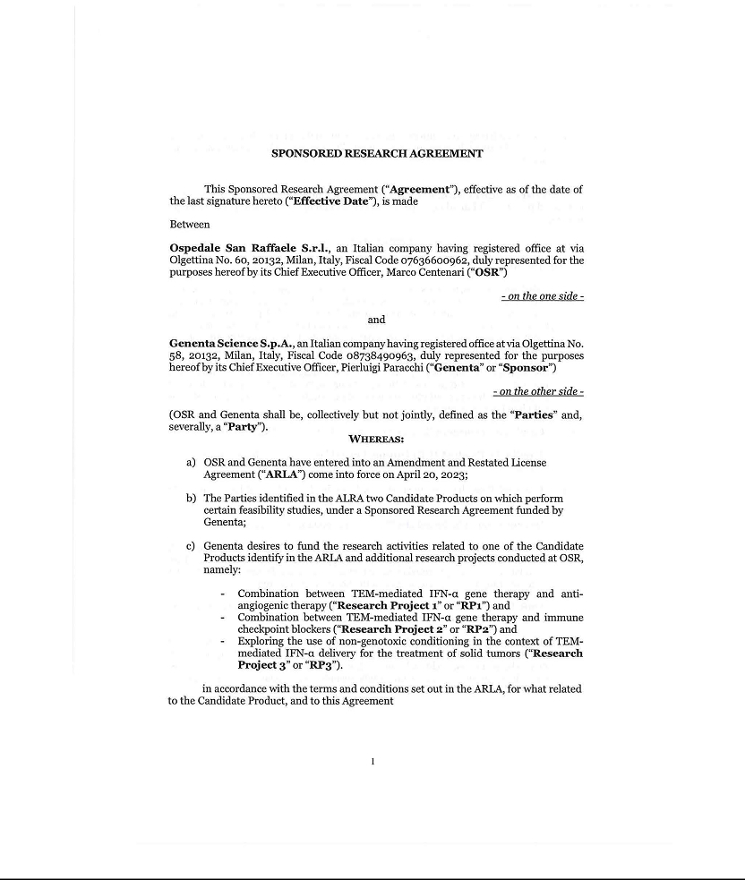

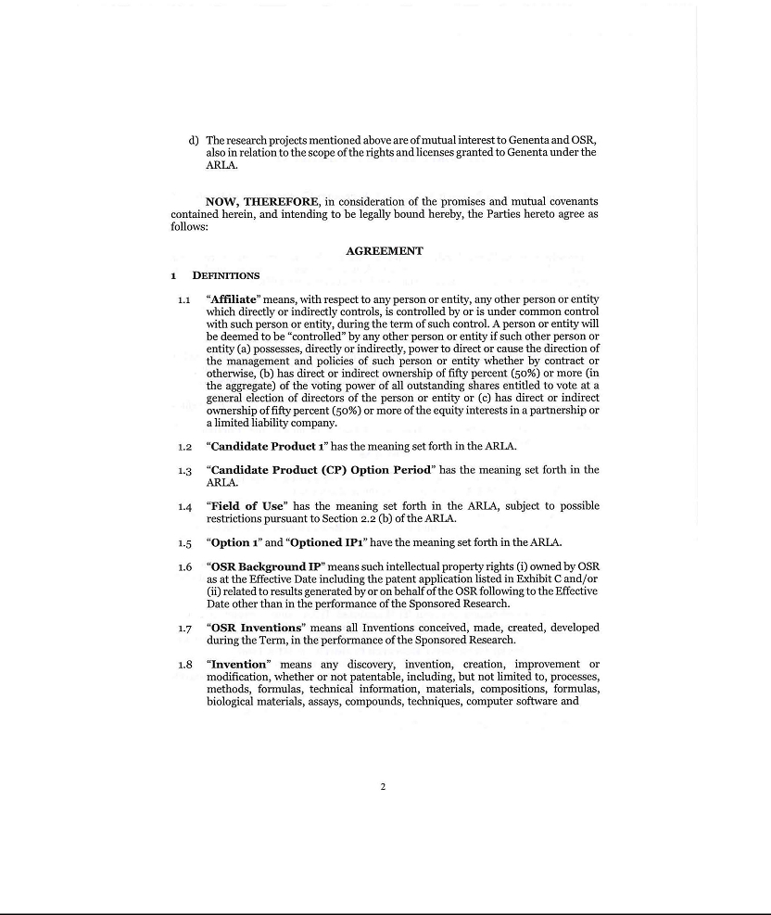

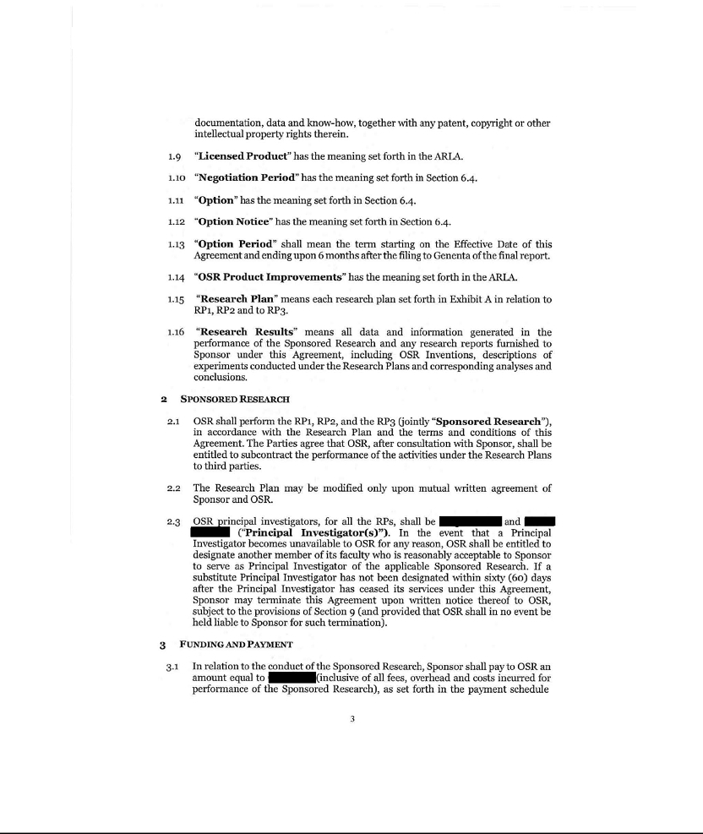

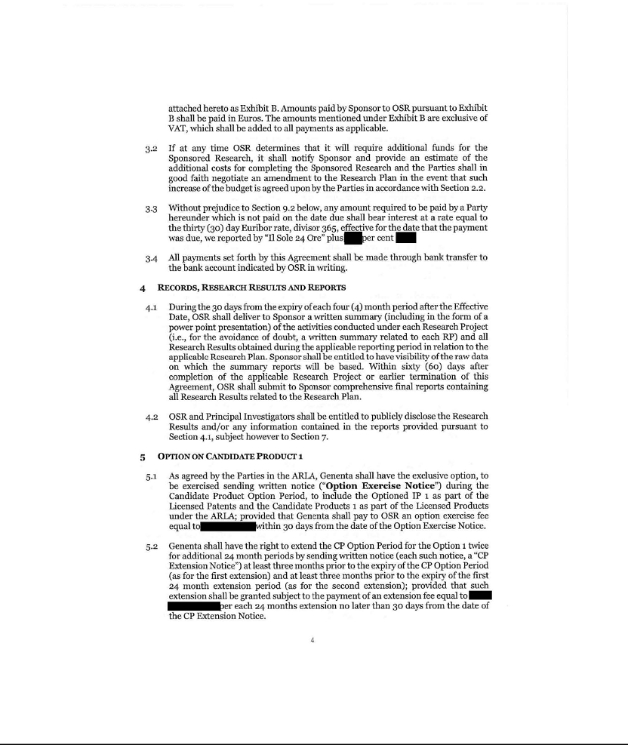

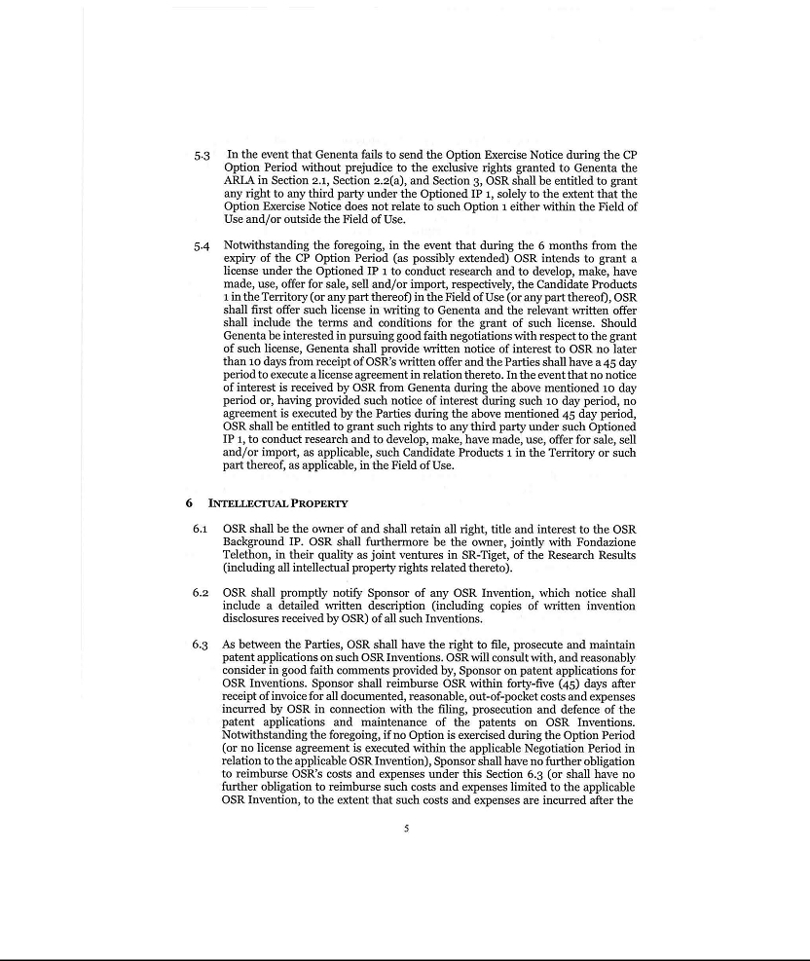

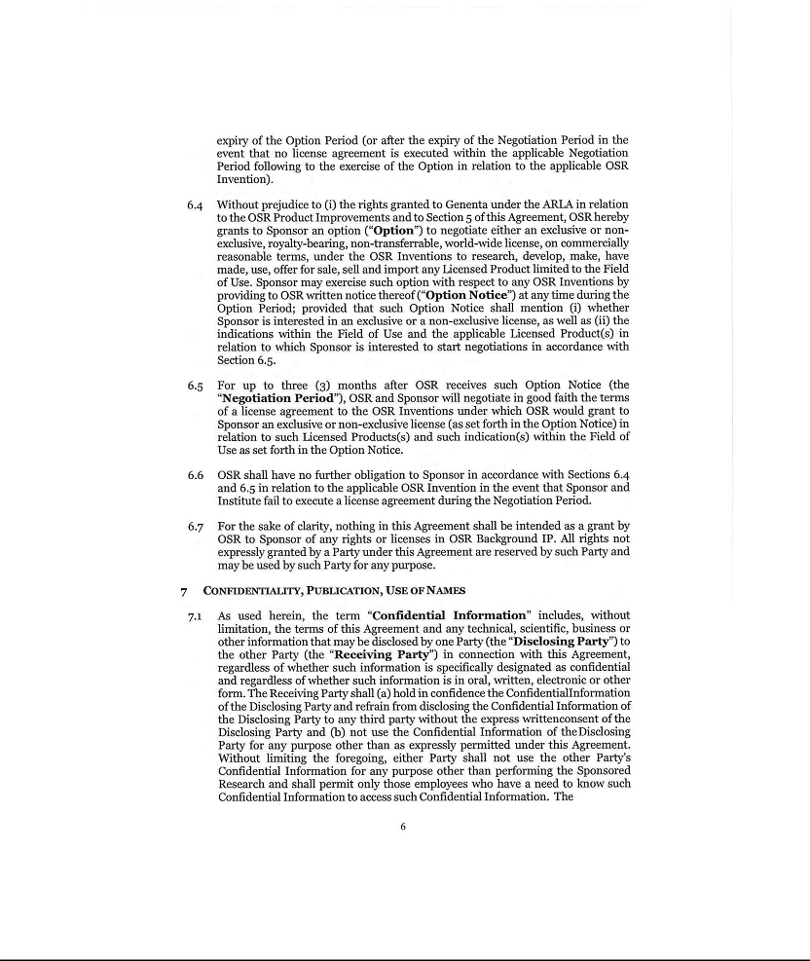

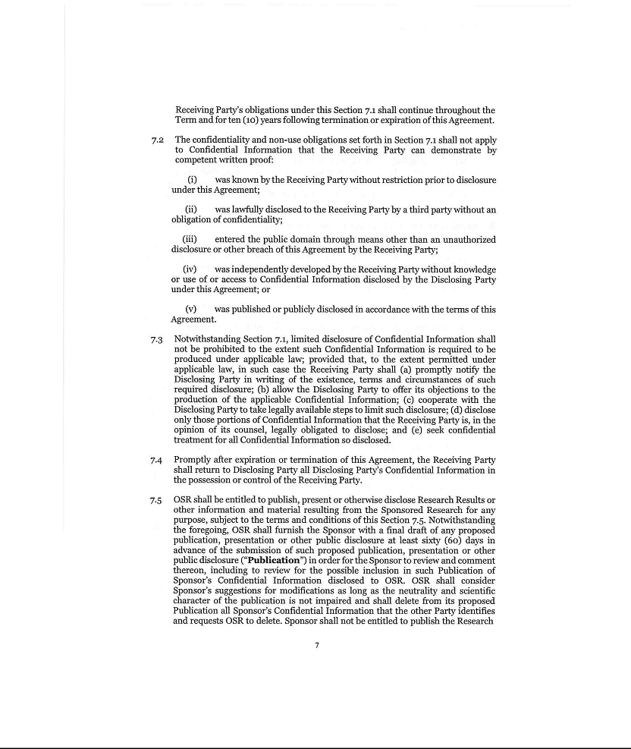

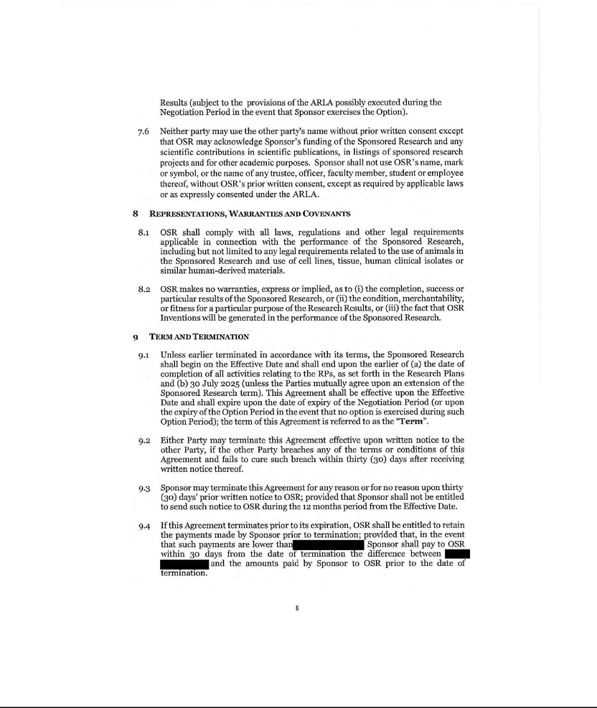

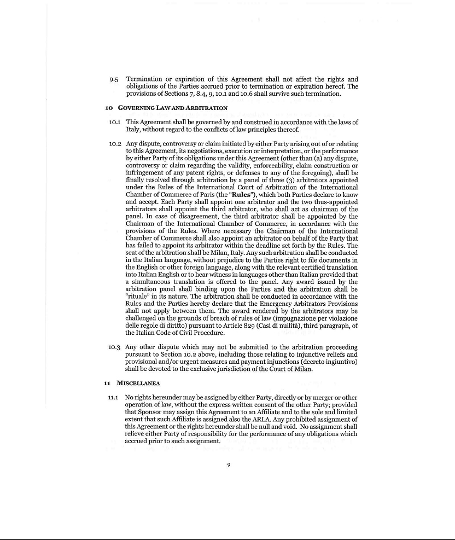

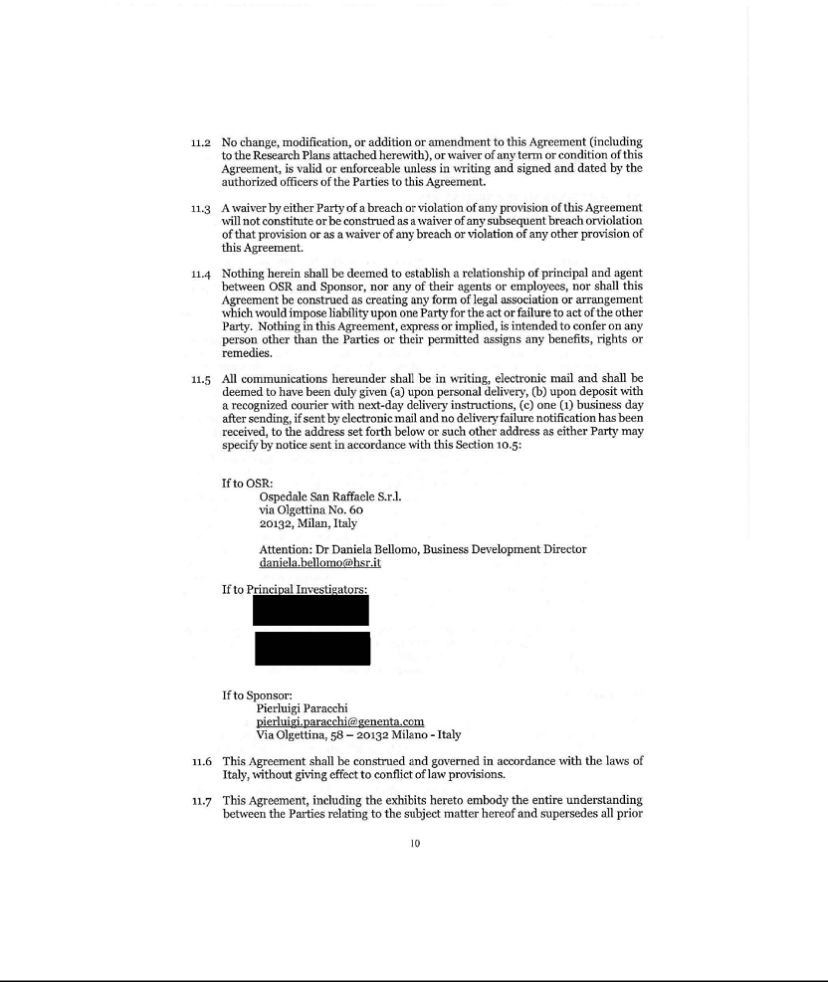

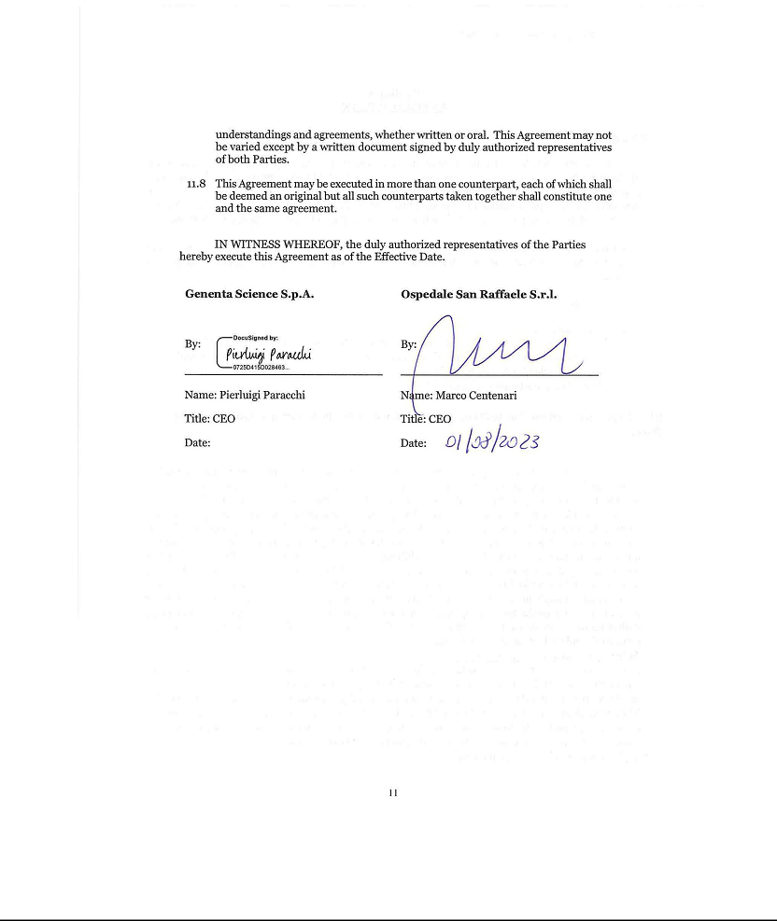

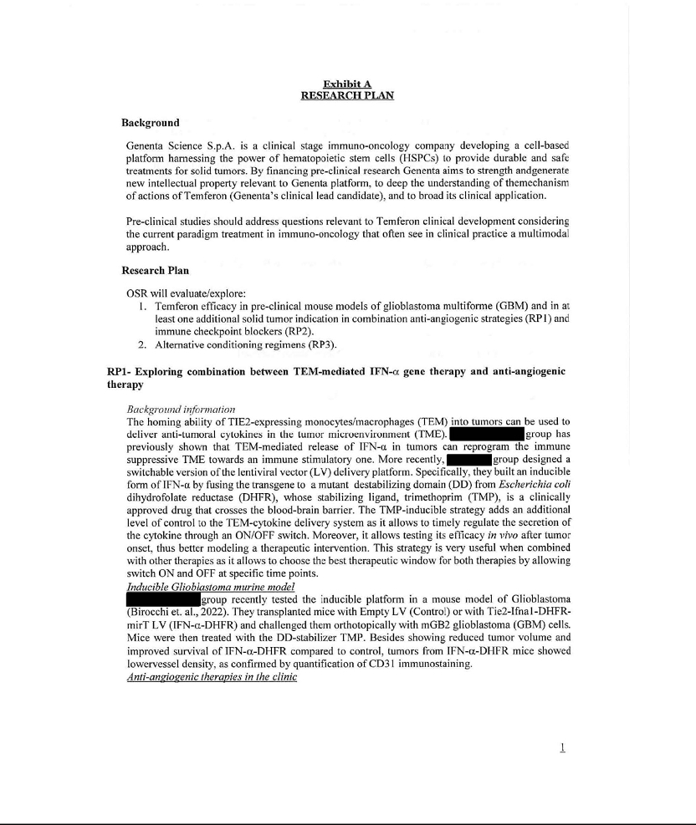

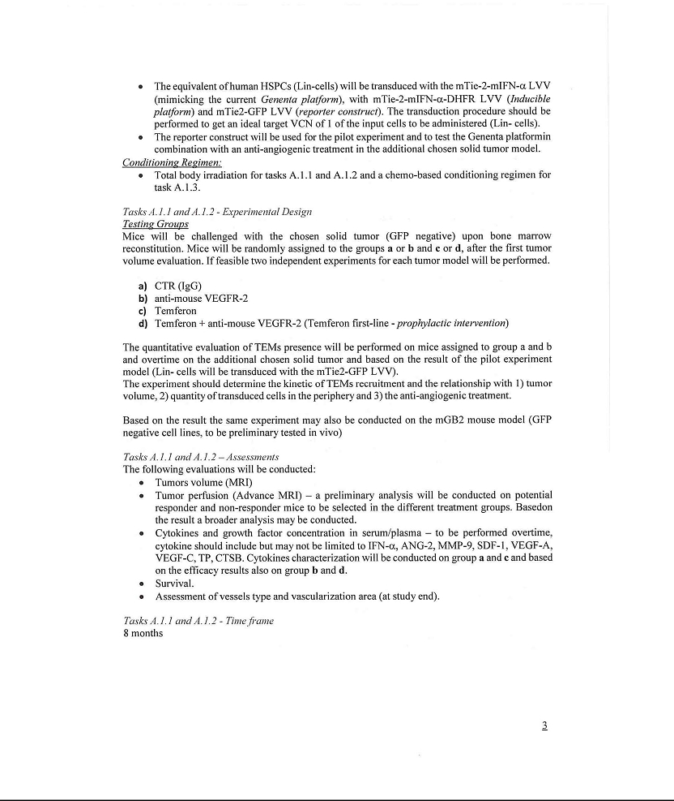

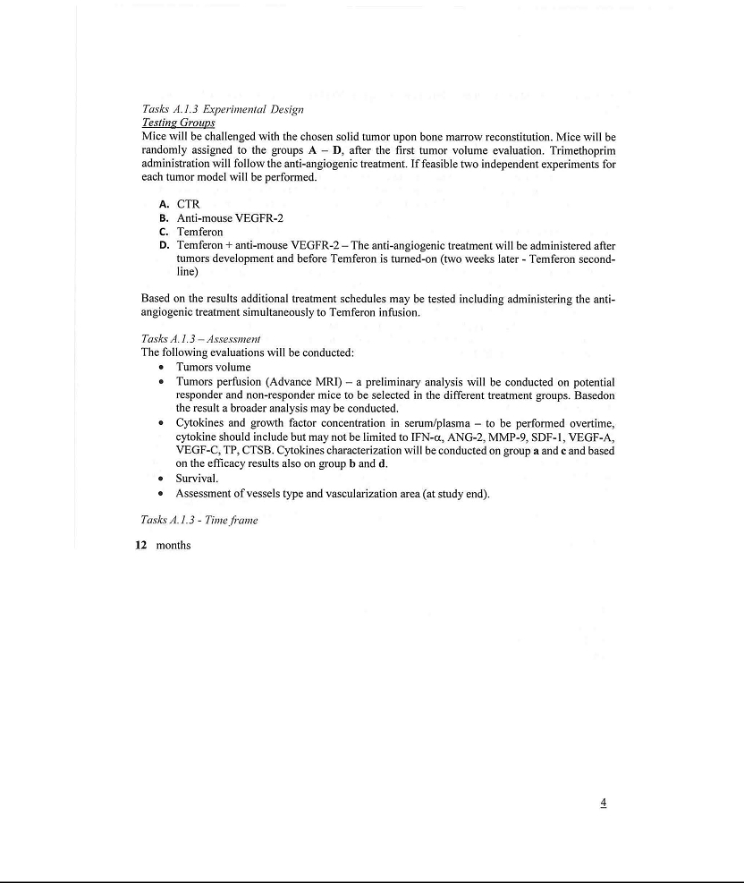

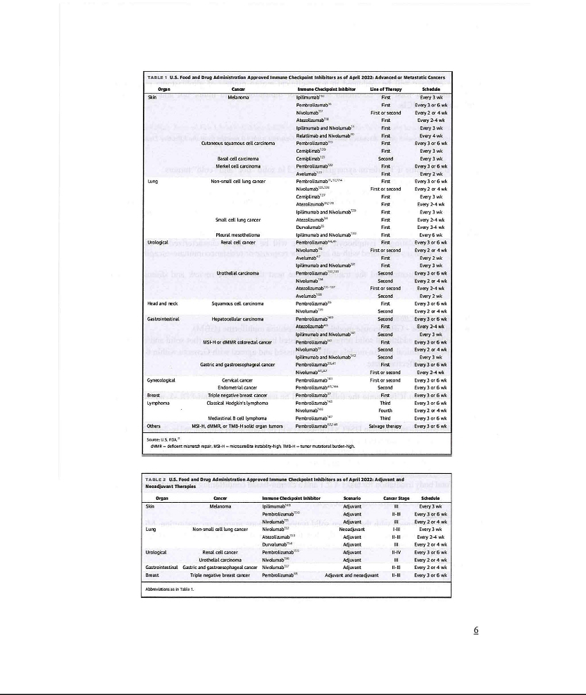

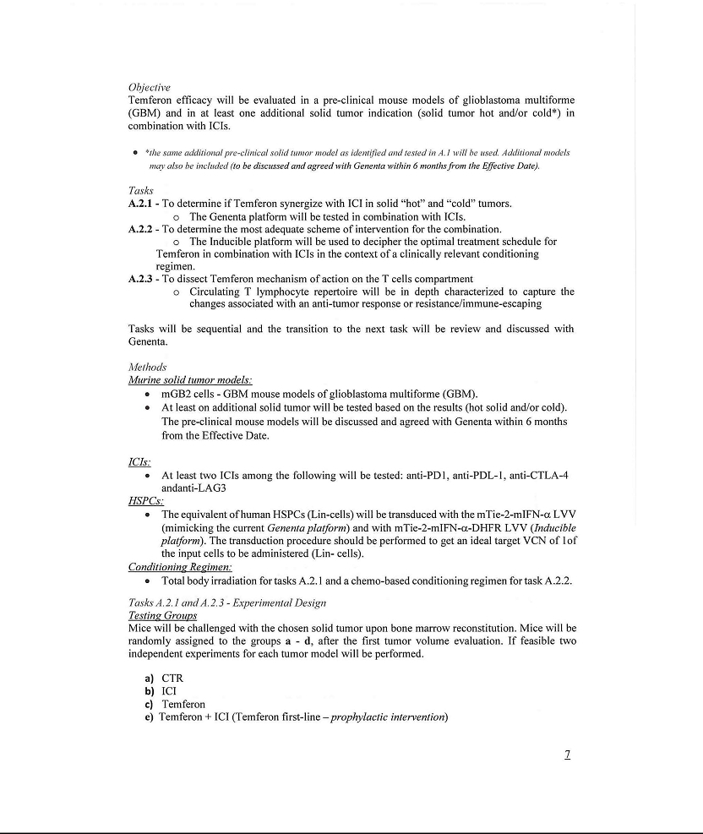

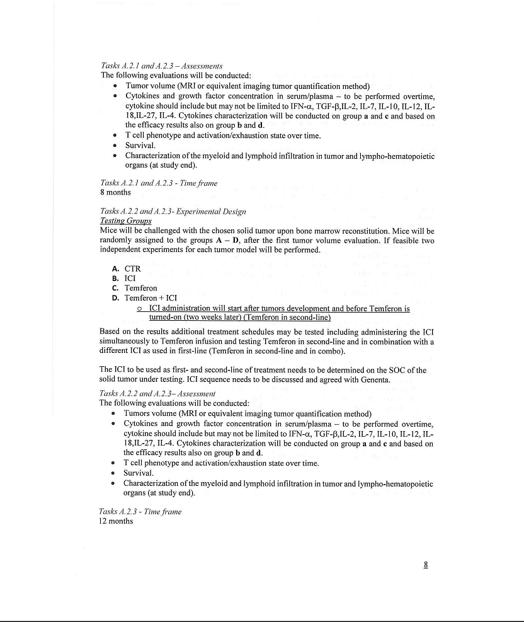

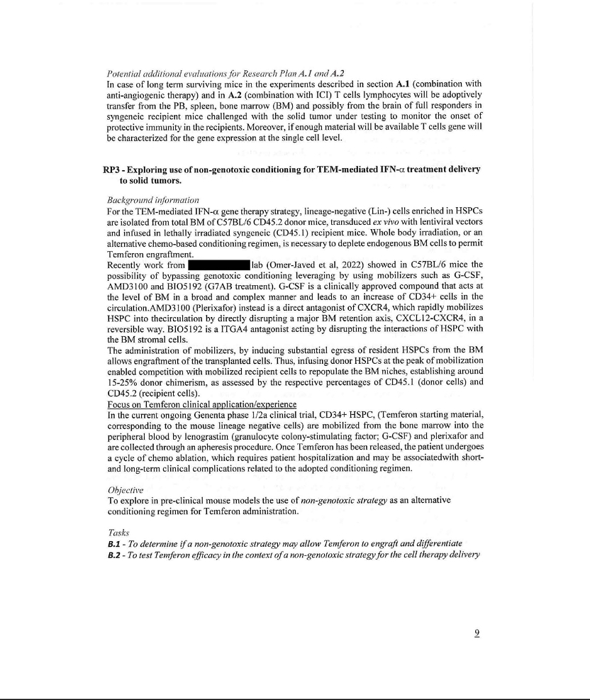

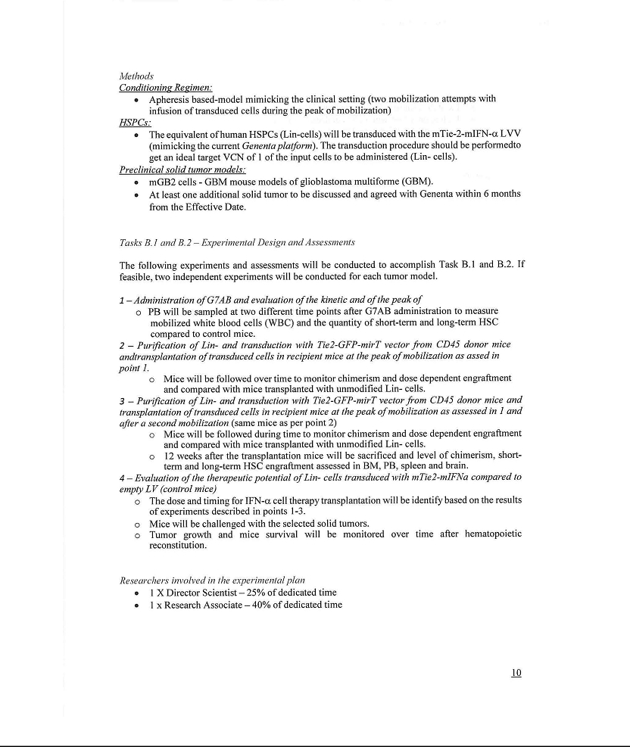

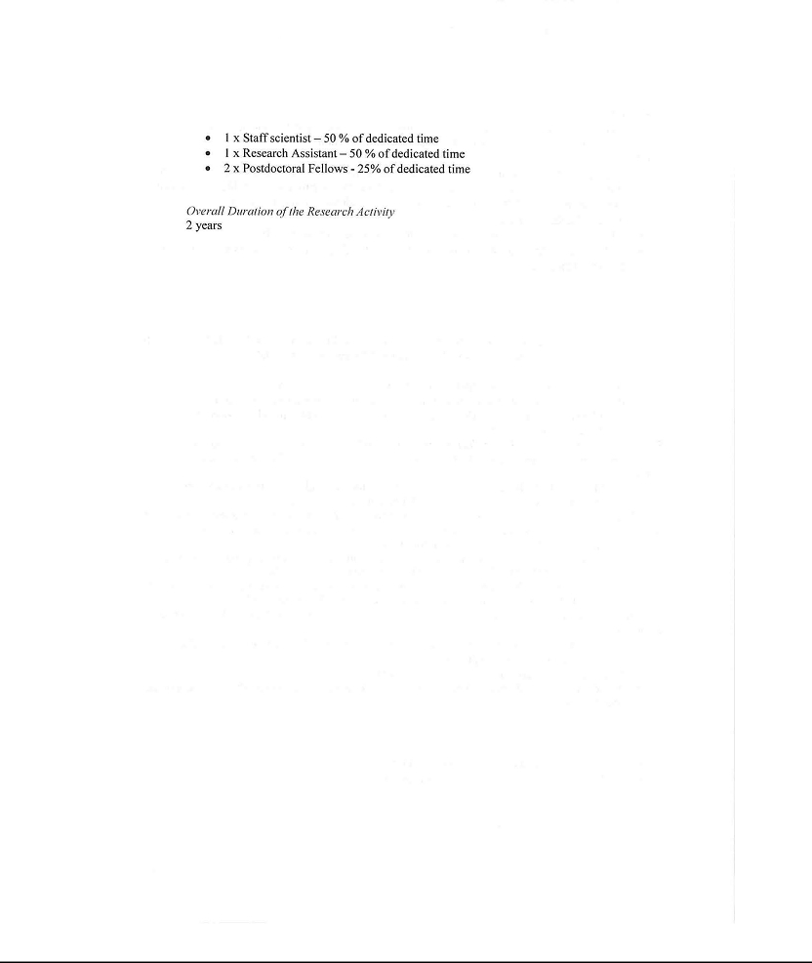

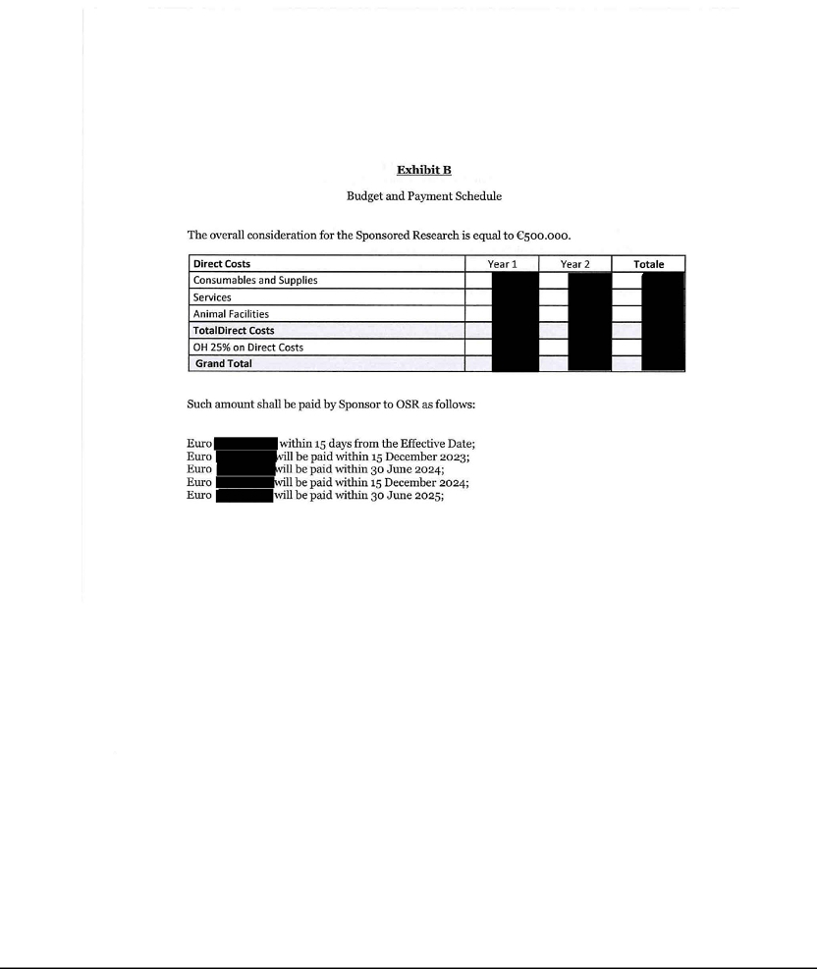

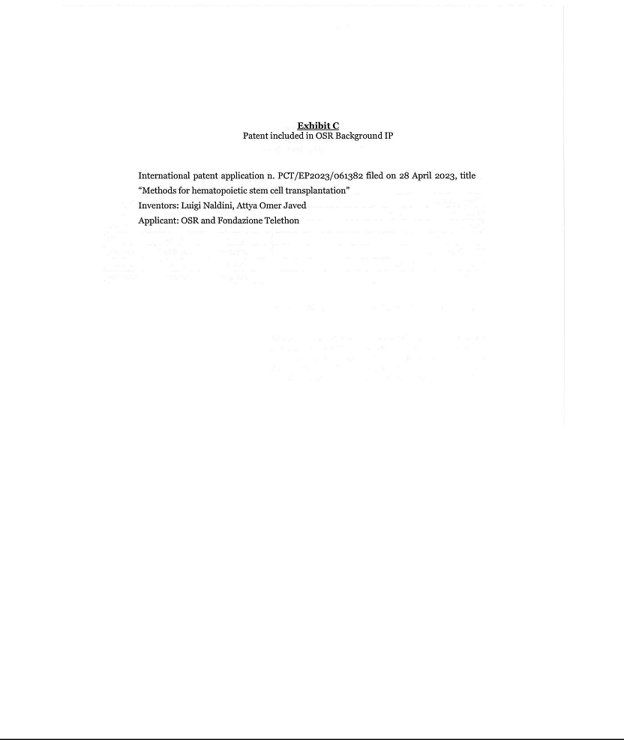

Exhibit 10.2
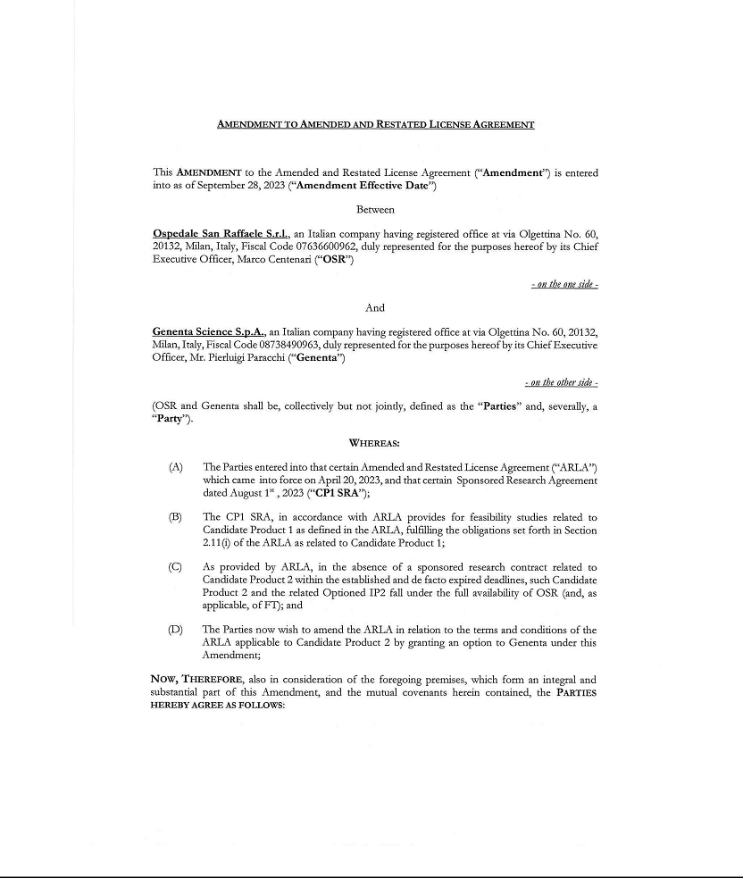

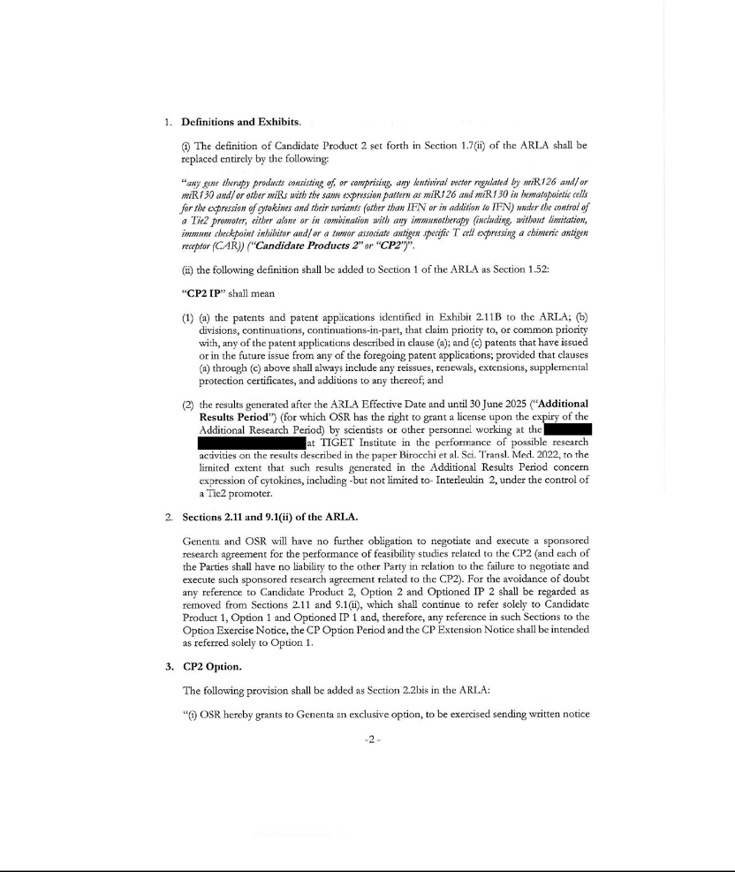

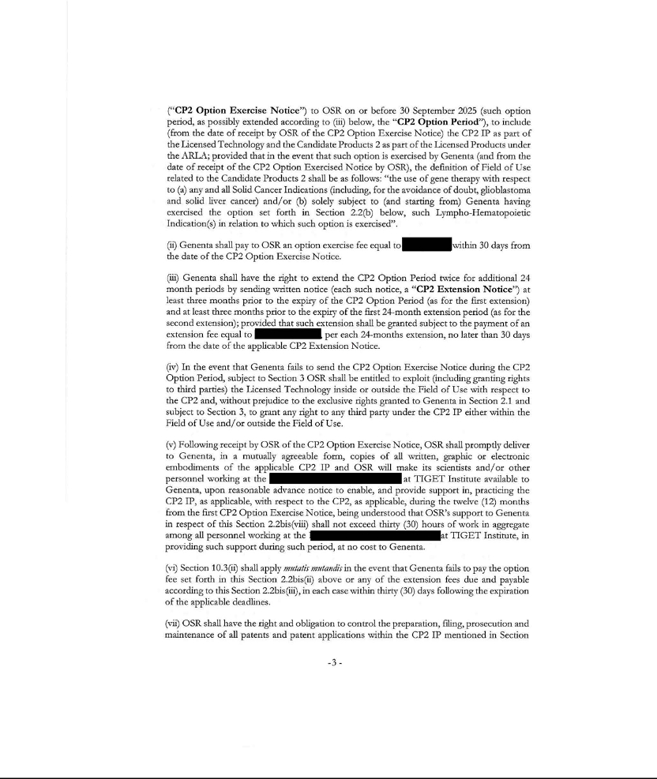

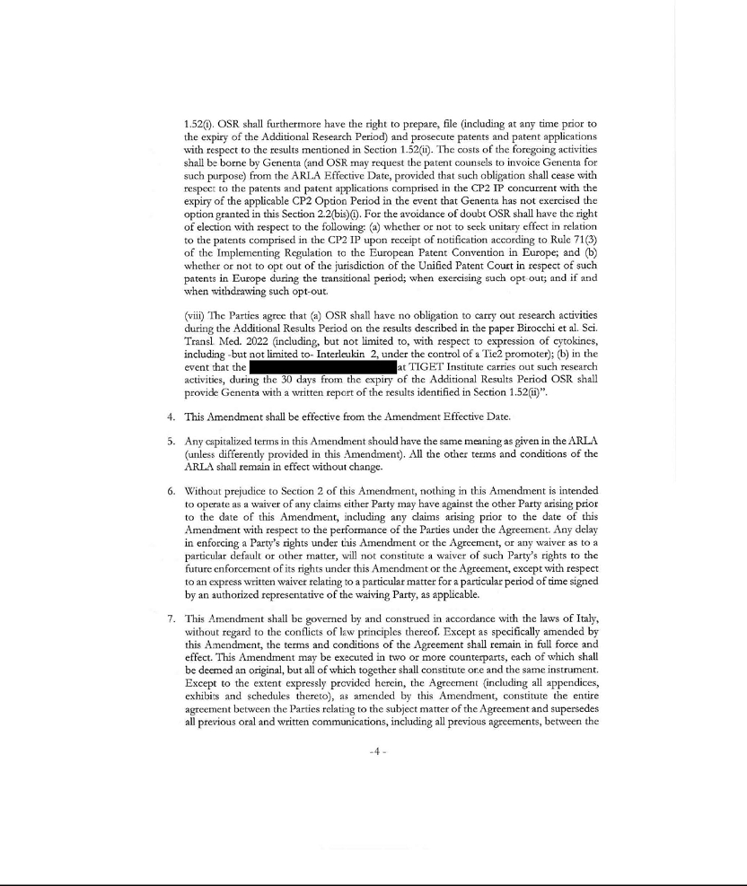

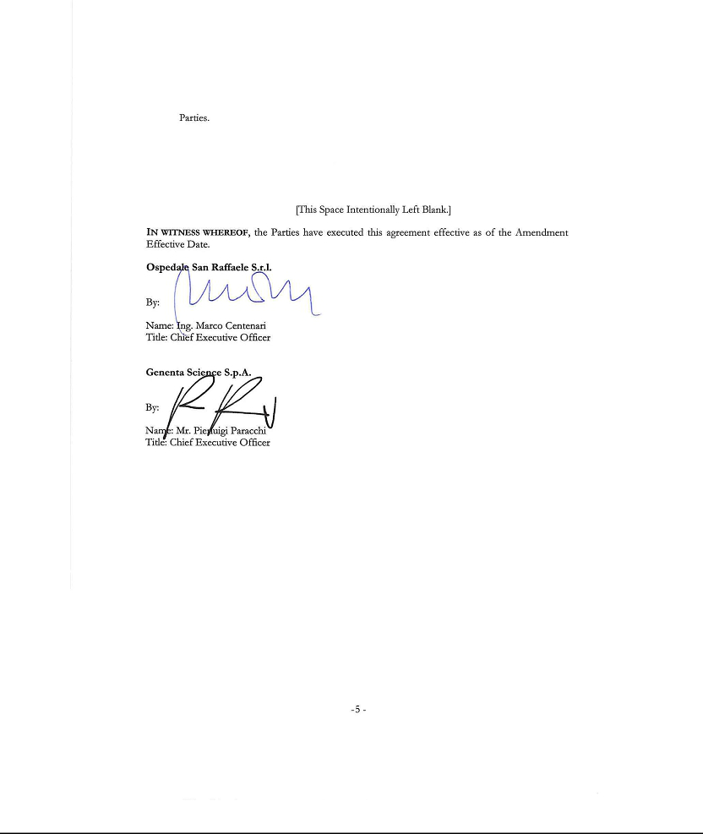

Exhibit 99.1

Genenta Science S.p.A.

Consolidated Statements of Operations and Comprehensive Loss

 |  |  | Six Months Ended June 30,
 |  |  | 2023 |  |  |  | 2022
 |  |  | (Unaudited)
Operating expenses
Research and development | € |  | 3,921,802 |  | € |  | 1,640,579
General and administrative |  |  | 2,878,373 |  |  |  | 2,513,558
Total operating expenses |  |  | 6,800,175 |  |  |  | 4,154,137
Loss from operations |  |  | (6,800,175) |  |  |  | (4,154,137)
Other income (expense)
Other income |  |  | 114,992 |  |  |  | 215,486
Finance income (expense) |  |  | 77,999 |  |  |  | -
Unrealized exchange rate gain (loss) |  |  | (152,041) |  |  |  | 1,826,330
Total other income (expense) |  |  | 40,950 |  |  |  | 2,041,816
Loss before income taxes |  |  | (6,759,225) |  |  |  | (2,112,321)
Income taxes benefit (expenses) |  |  | - |  |  |  | -
Net loss |  |  | (6,759,225 | ) |  |  | (2,112,321 | )
Net loss and comprehensive loss | € |  | (6,759,225) |  | € |  | (2,112,321)
Loss per share:
Loss | € |  | (6,759,225) |  | € |  | (2,112,321)
Loss per share – basic |  | € | (0.37 | ) |  | € | (0.12 | )
Weighted average number of shares outstanding – basic |  |  | 18,216,858 |  |  |  | 18,216,858

The accompanying notes are an integral part of these consolidated financial statements.

Genenta Science S.p.A.

Consolidated Balance Sheets

 |  |  | At June 30, |  |  |  | At December 31,
 |  |  | 2023 |  |  |  | 2022
 |  |  | (Unaudited)
Assets
Current assets
Cash and cash equivalents | € |  | 12,213,260 |  | € |  | 29,794,856
Marketable securities |  |  | 9,998,547 |  |  |  | -
Prepaid expenses and other current assets |  |  | 2,304,233 |  |  |  | 1,926,512
Total current assets |  |  | 24,516,040 |  |  |  | 31,721,368
Non-current assets
Fixed assets, net | € |  | 102,933 |  | € |  | 111,639
Other non-current assets |  |  | 2,103,732 |  |  |  | 1,601,503
Other non-current assets - related party |  |  | 3,350 |  |  |  | 3,350
Total non-current assets |  |  | 2,210,015 |  |  |  | 1,716,492
Total assets |  | € | 26,726,055 |  |  | € | 33,437,860
Liabilities and shareholders’ equity
Current liabilities
Accounts payable | € |  | 349,274 |  | € |  | 1,042,054
Accounts payable - related party |  |  | 130,220 |  |  |  | 151,988
Accrued expenses |  |  | 448,365 |  |  |  | 202,389
Accrued expenses - related party |  |  | 632,381 |  |  |  | 489,207
Other current liabilities |  |  | 211,272 |  |  |  | 297,875
Total current liabilities |  |  | 1,771,512 |  |  |  | 2,183,513
Non-current liabilities
Other non current liabilities |  |  | 21,004 |  |  |  | 27,218
Retirement benefit obligation |  |  | 129,449 |  |  |  | 88,963
Total long-term liabilities |  |  | 150,453 |  |  |  | 116,181
Commitments and contingencies |  |  | - |  |  |  | -
Shareholders’ equity
Ordinary shares, no par value, 59,700,000 shares authorized and 18,216,858 shares issued
and outstanding |  |  | 67,019,158 |  |  |  | 66,603,725
Accumulated deficit |  |  | (42,215,068) |  |  |  | (35,465,559)
Total shareholders’ equity |  |  | 24,804,090 |  |  |  | 31,138,166
Total liabilities and shareholders’ equity |  | € | 26,726,055 |  |  | € | 33,437,860

The accompanying notes are an integral part of these consolidated financial statements.

Genenta Science S.p.A.

Consolidated Statements of Changes in Shareholders’ Equity

 | Common shares |  |  | Common stock, |  |  | Accumulated
 | outstanding |  |  | no par value |  |  | deficit |  |  |  | Total
Balance at December 31, 2021 | 18,216,858 |  | € | 65,880,990 |  | € | (27,019,807 | ) |  | € | 38,861,183
Share-based compensation | - |  |  | 240,043 |  |  | - |  |  |  | 240,043
Net loss | - |  |  | - |  |  | (2,112,321) |  |  |  | (2,112,321)
Balance at June 30, 2022 (Unaudited) | 18,216,858 |  | € | 66,121,033 |  | € | (29,132,128 | ) |  | € | 36,988,905
Share-based compensation | - |  |  | 482,692 |  |  | - |  |  |  | 482,692
Cumulative translation adjustment | - |  |  | - |  |  | 32,011 |  |  |  | 32,011
Net loss | - |  |  | - |  |  | (6,365,442) |  |  |  | (6,365,442)
Balance at December 31, 2022 | 18,216,858 |  | € | 66,603,725 |  | € | (35,465,559 | ) |  | € | 31,138,166
Share-based compensation | - |  |  | 415,433 |  |  | - |  |  |  | 415,433
Cumulative translation adjustment | - |  |  | - |  |  | 9,716 |  |  |  | 9,716
Net loss | - |  |  | - |  |  | (6,759,225) |  |  |  | (6,759,225)
Balance at June 30, 2023 (Unaudited) | 18,216,858 |  | € | 67,019,158 |  | € | (42,215,068 | ) |  | € | 24,804,090

The accompanying notes are an integral part of these consolidated financial statements.

Genenta Science S.p.A.

Consolidated Statements of Cash Flows

 |  |  | Six Months Ended June 30,
 |  |  | 2023 |  |  |  | 2022
 |  |  | (in Euros)
Cash flows from operating activities
Net loss | € |  | (6,759,225) |  | € |  | (2,112,321)
Adjustments to reconcile net loss to net cash used in operating activities:
Cumulative translation adjustment |  |  | 9,716 |  |  |  | -
Depreciation expense |  |  | 21,143 |  |  |  | 2,813
Retirement benefit obligation |  |  | 40,486 |  |  |  | 24,574
Share-based compensation |  |  | 415,433 |  |  |  | 240,043
Gain on purchase of marketable securities |  |  | (9,517) |  |  |  | -
Changes in operating assets and liabilities
Prepaid expenses and other current assets |  |  | (377,721) |  |  |  | (1,218,085)
Other non-current assets |  |  | (502,229) |  |  |  | 443,114
Accounts payable |  |  | (692,780) |  |  |  | 83,092
Accounts payable - related party |  |  | (21,768) |  |  |  | 252,607
Accrued expenses |  |  | 245,976 |  |  |  | (329,451)
Accrued expenses - related party |  |  | 143,174 |  |  |  | 40,218
Other current liabilities |  |  | (86,603) |  |  |  | 7,203
Other non-current liabilities |  |  | ) |  |  |  | -
Other non-current liabilities |  |  | (6,214 |  |  |  | -
Net cash used in operating activities |  |  | (7,580,129 | ) |  |  | (2,566,193 | )
Cash flows from investing activities
Purchase of marketable securities |  |  | (9,989,030) |  |  |  | -
Purchases of fixed assets |  |  | ) |  |  |  | (2,813 | )
Purchases of fixed assets |  |  | (12,437 |  |  |  | (2,813
Net cash used in investing activities |  |  | (10,001,467 | ) |  |  | (2,813 | )
Cash flows from financing activities
Financing activities |  |  | - |  |  |  | -
Net cash provided by financing activities |  |  | - |  |  |  | -
Net increase (decrease) in cash and cash equivalents |  |  | (17,581,596) |  |  |  | (2,569,006)
Cash and cash equivalents at beginning of period |  |  | 29,794,856 |  |  |  | 37,240,162
Cash and cash equivalents at end of period |  | € | 12,213,260 |  |  | € | 34,671,156

The accompanying notes are an integral part of these consolidated financial statements.

Genenta Science S.p.A.

Notes to the Consolidated Financial Statements

1. Nature of business and history

Genenta Science S.p.A. (the “Company” or “Genenta” - formerly Genenta Science S.r.l., a “società a responsabilità limitata” or “S.r.l,” which is similar to a limited liability company in the United States) converted to an Italian joint stock company (a “società per azioni” or “S.p.A.”) in June 2021, which is similar to a C corporation in the United States. The Company was founded in Milan, Italy by San Raffaele Hospital (“OSR”), Pierluigi Paracchi, Luigi Naldini and Bernhard Gentner, and was incorporated in July 2014. On May 20, 2021, the quotaholders (owners of the Company) resolved that the Company convert from an S.r.l. to an S.p.A., determined that the outstanding quota be converted to 15 million ordinary shares at no par value and adopted new Bylaws. The registered office remained located in Milan, Italy. The Company’s reporting currency is Euros (“EUR” or “€”).

In May 2021, the Company formed a wholly owned Delaware incorporated subsidiary, Genenta Science, Inc., intended for future operations in the United States (“US Subsidiary”). The US Subsidiary operates in US Dollars (“USD” or “$”).

On December 17, 2021, the Company completed an initial public offering (“IPO”) of its shares. The shares began trading on the Nasdaq Stock Capital Market (“Nasdaq”) on December 15, 2021.Through the IPO, 3,120,114 new ordinary shares with no par value were issued. 720,114 ordinary shares were subscribed by the Company’s existing shareholders through a reserved offering, while 2,400,000 American Depository Shares (“ADSs”), each representing one of the Company’s ordinary shares, were offered to the public and listed on Nasdaq. Subsequently, on December 27, 2021, the Company’s underwriter exercised a portion of its “green shoe” allotment for an additional 96,744 ADSs. The total number of shares outstanding resulting at December 31, 2021 was 18,216,858. Through the IPO, approximately €29 million was raised, net of listing costs (approximately €3.9 million). There were no additional ordinary shares issued from December 31, 2021 to June 30, 2023.

On May 12, 2023, the Company filed with the Securities and Exchange Commission (the “SEC”) a shelf registration statement (the “Shelf Registration Statement”) that was subsequently declared effective on May 24, 2023. It permits the Company to sell from time-to-time ordinary shares, including ordinary shares represented by ADSs, or rights to subscribe for ordinary shares or ordinary shares represented by ADSs in one or more offerings in amounts, at prices and on the terms that the Company will determine at the time of offering for aggregate gross sale proceeds of up to $100.0 million.

The Company may offer and sell up to $30.0 million ordinary shares in the form of ADSs from time to time pursuant to a Controlled Equity OfferingSM Sales Agreement, dated May 12, 2023 (the “Sales Agreement”), between the Company and Cantor Fitzgerald & Co. (“Cantor”), as agent, subject to the terms and conditions described in the Sales Agreement and SEC rules and regulations (the “ATM Offering”).

Genenta is an early-stage company developing first-in-class cell and gene therapies to address unmet medical needs in cancerous solid tumors. The Company is initially developing its clinical leading product, Temferon™, to treat glioblastoma multiforme (“GBM”), a solid tumor affecting the brain. The Company intends to continue its clinical trials in Europe and eventually start a clinical trial in the United States to study Temferon™ in other cancers. In June 2023, the Company’s Board of Directors (the “Board”) selected Renal Cell Cancer (“RCC”) as the second solid tumor indication for Temferon. The Company is developing a clinical plan for RCC.

The Company is subject to risks and uncertainties common to early-stage clinical companies in the life-science and biotechnology industries, including but not limited to, risks associated with completing preclinical studies and clinical trials, receiving regulatory approvals for product candidates, development by competitors of new competing products, dependence on key personnel, protection of proprietary technology, compliance with government regulations and the ability to secure additional capital to fund operations. The clinical product candidates currently under development will require significant additional research and development efforts, including regulatory approval and clinical testing prior to commercialization. These efforts require significant amounts of additional capital, adequate personnel and infrastructure and extensive compliance-reporting capabilities in Italy, Europe and the United States. Even if the Company’s product development efforts are successful, it is uncertain when, if ever, the Company will realize revenue from product sales and profit from operations.

Liquidity and risks

The Company has incurred losses since its inception, including a net loss of €6.8 million and €2.1 million for the six months ended June 30, 2023, and June 30, 2022, respectively. In addition, at June 30, 2023, the Company had an accumulated deficit of €42.2 million. The Company has primarily funded these losses through the proceeds from sales of convertible debt and equity quotas, prior to the Company’s conversion into an S.p.A., and then through the proceeds from its IPO. Although the Company has incurred recurring losses and expects to continue to incur losses for the foreseeable future, the Company expects that its existing cash and cash equivalents on hand of €12.2 million, together with the other short term marketable securities of €10.0 million as of June 30, 2023, will be sufficient to fund current planned operations and capital expenditure requirements for at least the next twelve months from the filing date of these consolidated financial statements. However, the future viability of the Company is dependent on its ability to raise additional capital to finance its operations. The Company’s inability to raise capital as and when needed could have a negative impact on its financial condition and ability to pursue its business strategies. There can be no assurance that the current operating plan will be achieved or that additional funding will be available on terms acceptable to the Company, or at all.

The Company has evaluated whether there are conditions and events considered in the aggregate that raise substantial doubt about the Company’s ability to continue as a going concern. The Company’s business model, typical of biotechnology and life science companies developing new therapeutic products that have not reached a balanced income and financial position, features negative cash flows. This is because, at this stage, costs must be borne in relation to services and personnel, directly connected to research and development, and clinical activities, and return for these activities is not certain and, in any case, it is expected in future years. Based on the accounting policies adopted, requiring full recognition of research and development, and clinical costs in the statement of operations and comprehensive loss in the year they are incurred, the Company has reported a loss since its inception, and expects to continue to incur significant research and development, and clinical costs in the foreseeable future. There is no certainty that the Company will become profitable in the future.

The Company’s ability to raise additional capital may be adversely impacted by the potential worsening of global economic and political conditions and volatility in the credit and financial markets in the United States and worldwide. This could be exacerbated by, among other factors, the lingering effects of the COVID-19 pandemic and its ongoing variants and/or the war between Russia and Ukraine. The Company’s failure to raise capital as and when needed or on acceptable terms would have a negative impact on the Company’s financial condition and its ability to pursue its business strategy, and the Company may have to delay, reduce the scope of, suspend or eliminate one or more of its research-stage programs, clinical trials, or future commercialization efforts.

As stated, the Company will require additional capital to meet its long-term operating requirements. It expects to raise additional capital through, among other things, the sale of equity or debt securities, which may include sales of ADSs pursuant to the ATM Offering. If adequate funds are not available in the future, the Company may be forced to delay, reorganize, or cancel research and development and/or clinical programs, or to enter into financing, licensing or collaboration agreements with unfavorable conditions or waive rights to certain products which otherwise it would not have waived, resulting in negative effects on the activity and on the economic, patrimonial and /or financial situation of the Company.

Quantitative and qualitative disclosure about market risk

The Company is exposed to market risks in the ordinary course of its business. Market risk represents the risk of loss that may impact the Company’s financial position due to adverse changes in financial market prices and rates. The Company’s current investment policy is conservative due to the need to support operations. The Company invests available cash in bank time deposits with reputable banks that have a credit rating of at least “A” and Italian and United States government treasury notes and bonds with short term maturity. A minority of the Company’s cash and cash equivalents is held in deposits that bear a small amount of interest. The Company’s market risk exposure is primarily a result of foreign currency exchange rates, which is discussed in detail in the following paragraph.

The Company is an early-stage cell and gene therapy company commercializing technology licensed from OSR. The Company intends to continue to conduct its operations so that neither it nor its subsidiary is required to register as an investment company under the Investment Company Act of 1940, as amended, and the rules and regulations promulgated thereunder (the “‘40 Act”). To ensure that the Company does not become subject to regulation under the ‘40 Act, the Company may be limited in the type of assets that it may own or acquire. If the Company were to become inadvertently subject to the ‘40 Act, any violation of the ‘40 Act could subject the Company to material adverse consequences.

Foreign currency exchange risk

The Company’s results of operations and cash flow may be subject to fluctuations due to changes in foreign currency exchange rates. The Company’s liquid assets and expenses are denominated in EUR and USD. (At June 30, 2023, the Company maintained €12.2 million in cash and cash equivalents and €10.0 million in marketable securities. Changes in the USD/EUR exchange rate could increase/decrease the Company’s operating expenses, especially as more costs are incurred in the United States or, as USD are exchanged for EUR to cover European operating costs. As the Company continues to grow its business, the Company’s results of operations and cash flows might be subject to significant fluctuations due to changes in foreign currency exchange rates, which could adversely impact the Company’s results of operations.

Currently, the Company has recorded an unrealized net loss from exchange rate of approximately €0.2 million. The Company does not currently hedge its foreign currency exchange risk. In the future, the Company may enter formal currency hedging transactions to decrease the risk of financial exposure from fluctuations in the exchange rates of its principal operating currencies. These measures, however, may not adequately protect the Company from the material adverse effects of such fluctuations.

2. Summary of significant accounting policies

Basis of presentation

The consolidated financial statements of the Company are unaudited and have been prepared in accordance with generally accepted accounting principles in the United States of America (“U.S. GAAP”) for interim financial reporting and in accordance with Regulation S-X, Rule 10-01 promulgated by the Securities and Exchange Commission (“SEC”). Accordingly, the financial statements may not include all the information and footnotes required by U.S. GAAP for complete financial statements. Any reference in these notes to applicable guidance is meant to refer to the authoritative U.S. GAAP as found in the Accounting Standards Codification, or ASC, and Accounting Standards Update (“ASU”) of the Financial Accounting Standards Board (“FASB”).

The accompanying unaudited consolidated financial statements should be read in conjunction with the audited consolidated financial statements and accompanying notes included in the Company’s Annual Report on Form 20-F filed with the SEC on April 21, 2023. The balance sheet as of December 31, 2022 was derived from audited consolidated financial statements included in the Company’s Annual Report but does not include all disclosures required by U.S. GAAP.

Certain information and footnote disclosures normally included in financial statements prepared in accordance with U.S. GAAP have been condensed or omitted from these interim financial statements. However, these interim financial statements include all adjustments, consisting only of normal recurring adjustments, which are, in the opinion of the Company’s management, necessary to fairly state the results of the interim period. The interim results are not necessarily indicative of results to be expected for the full year.

A summary of the significant accounting policies applied in the preparation of these consolidated financial statements is presented below, only for the categories and headings now applicable and that might be applicable in the future based on the Company’s business. These policies have been consistently applied, unless otherwise stated.

Principles of consolidation

The accompanying consolidated financial statements include the accounts of the Company and its wholly owned subsidiary. All significant intercompany accounts and transactions have been eliminated in consolidation.

Use of estimates

The preparation of financial statements in conformity with U.S. GAAP requires management to make estimates and assumptions that affect the reported amounts reported in the financial statements and the disclosures made in the accompanying notes. Estimates and assumptions reflected in these consolidated financial statements include, but are not limited to, the accrual for research and development and clinical expenses and related milestone payments, share-based compensation expense, valuation of research and development tax credits, the valuation of equity and the recoverability of the Company’s net deferred tax assets and related valuation allowance. Estimates are periodically reviewed considering changes in circumstances, facts, and experience. Actual results may differ from these estimates under different assumptions or conditions. Changes in estimates are recorded in the period in which they become known. The areas involving a higher degree of judgment or complexity, or areas where assumptions and estimates are significant to the consolidated financial statements are disclosed below.

Cash and cash equivalents

The Company considers all highly liquid investments purchased with original maturities of 90 days or less at acquisition to be cash equivalents, which amounts may at times exceed federally insured limits. The Company has not experienced any losses on such accounts and does not believe it is exposed to any significant credit risk. In the consolidated cash flow statements, cash and cash equivalents include cash on hand. In the consolidated balance sheets, bank overdrafts, if any, are shown in current liabilities. Cash and cash equivalents are detailed as follows:

 |  | At June 30, |  |  |  | At December 31,
 |  | 2023 |  |  |  | 2022
(in Euros) |  | (Unaudited)
Cash in bank | € | 12,209,242 |  | € |  | 29,790,838
Cash in hand & prepaid cards |  | 4,018 |  |  |  | 4,018
Total | € | 12,213,260 |  |  | € | 29,794,856

Net loss and comprehensive loss

Comprehensive loss is defined as the change in equity during a period from transactions and other events and circumstances from non-owner sources. ASC 220 Comprehensive Income requires that an entity records all components of comprehensive (loss) income, net of their related tax effects, in its financial statements in the period in which they are recognized. For the six months ended June 30, 2023, and June 30, 2022, the comprehensive loss was equal to net loss.

Net loss per share

Net loss per share (“EPS”) is computed in accordance with U.S. GAAP. Basic EPS is computed by dividing net loss by the weighted average number of ordinary shares outstanding during the period. Diluted EPS reflects potential dilution and is computed by dividing net loss by the weighted average number of ordinary shares outstanding during the period increased by the number of additional ordinary shares that would have been outstanding if all potential ordinary shares had been issued and were dilutive.

The EPS calculation was applied at the Company conversion to S.p.A. in June 2021. The Company’s shareholders authorized 59.7 million ordinary shares. The Company has 18,216,858 ordinary shares issued and outstanding at June 30, 2023, which has not changed since the IPO, with 2.7 million ordinary shares reserved for the Company’s Equity Incentive Plan 2021–2035.

At June 30, 2023 and June 30, 2022, the Company had options on 318,459 and 147,783 ordinary shares outstanding, respectively, and 23,502 ordinary share equivalents, in the form of underwriters’ ordinary share warrants.

Diluted EPS was not relevant at June 30, 2023 and June 30, 2022, as the effect of ordinary share equivalents, in the form of 23,502 underwriters’ ordinary share warrants, and options on 318,459 and 147,783 ordinary shares, respectively, would have been anti-dilutive. (See Note 10. Shareholders’ equity and Note 11. Share-based compensation.)

Foreign currency translation

The reporting and functional currency of the Company is Euros. All amounts are presented in Euros unless otherwise stated. All amounts disclosed in the consolidated financial statements and notes have been rounded to the nearest Euro unless otherwise stated. Foreign currency transactions, if any, are translated into Euros using the exchange rates prevailing at the date(s) of the transaction(s) or valuation where items are re-measured. Foreign exchange gains and losses resulting from the settlement of such transactions and from the translation at period-end exchange rates of monetary assets and liabilities denominated in foreign currencies are recognized in the Company’s Consolidated Statements of Operations and Comprehensive Loss. For financial reporting purposes, the assets and liabilities of the US Subsidiary are translated into EUR using exchange rates in effect at the balance sheet date. The net profit/(loss) of the US Subsidiary is translated into EUR using average exchange rates in effect during the reporting period. The resulting currency translation impact is recorded in Shareholders’ equity as a cumulative translation adjustment. At June 30, 2023 and June 30, 2022, the currency translation impact was not material.

During the six months ended June 30, 2023, the unrealized foreign exchange net loss was €0.2 million. During the six months ended June 30, 2022, the unrealized foreign exchange net gain was €1.8 million. The change in the net foreign exchange rate effect was due to the fluctuation in the USD exchange rate with the Euro.

Emerging growth company status

The Company is an “emerging growth company,” as defined in the Jumpstart Our Business Startups Act (the “JOBS Act”) and may take advantage of certain exemptions from various reporting requirements that are applicable to other public companies that are not emerging growth companies. The Company may take advantage of these exemptions until the Company is no longer an “emerging growth company.” Section 107 of the JOBS Act provides that an “emerging growth company” can take advantage of the extended transition period afforded by the JOBS Act for the implementation of new or revised accounting standards. The Company has elected to use the extended transition period for complying with new or revised accounting standards and, because of this election, its consolidated financial statements may not be comparable to companies that comply with public company effective dates. The Company may take advantage of these exemptions up until the last day of the fiscal year following the fifth anniversary of its IPO or such earlier time that it is no longer an “emerging growth company.”

Fair value measurements

Certain assets and liabilities of the Company are carried at fair value under U.S. GAAP. Fair value is defined as the exchange price that would be received for an asset or paid to transfer a liability (an exit price) in the principal or most advantageous market for the asset or liability in an orderly transaction between market participants on the measurement date. Valuation techniques used to measure fair value must maximize the use of observable inputs and minimize the use of unobservable inputs. Financial assets and liabilities carried at fair value are to be classified and disclosed in one of the following three levels of the fair value hierarchy, of which the first two are considered observable and the last is considered unobservable:

- Level 1 — Quoted prices in active markets for identical assets or liabilities.

- Level 2 — Observable inputs (other than Level 1 quoted prices), such as quoted prices in active markets for similar assets or liabilities, quoted prices in markets that are not active for identical or similar assets or liabilities, or other inputs that are observable or can be corroborated by observable market data.

- Level 3 — Unobservable inputs that are supported by little or no market activity that are significant to determining the fair value of the assets or liabilities, including pricing models, discounted cash flow methodologies and similar techniques.

To the extent that the valuation is based on models or inputs that are less observable or unobservable in the market, the determination of fair value requires more judgment. Accordingly, the degree of judgment exercised by the Company in determining fair value is greatest for instruments categorized in Level 3. A financial instrument’s level within the fair value hierarchy is based on the lowest level of any input that is significant to the fair value measurement.

The carrying values of the Company’s research and development tax credits, VAT credits, accounts payable, accrued expenses and other current liabilities approximate their fair values due to the short-term nature of these assets and liabilities.

 |  |  |  |  | June 30, 2023
 |  | Total |  |  | Level 1 |  | Level 2 |  |  |  | Level 3
Marketable Securities | € | 9,998,547 |  | € | 9,998,547 |  | € | - |  | € | -
Total financial assets | € | 9,998,547 |  | € | 9,998,547 |  | € | - |  | € | -

The Company invests in highly rated foreign government debt securities, with the primary objective of minimizing the potential risk of principal loss. The unrealized gain recognized during the reporting period on trading securities still held at the report date was €9,517.

Segment information

Operating segments are identified as components of an enterprise for which separate discrete financial information is available for evaluation by the chief operating decision-maker in making decisions regarding resource allocation and assessing performance. The Company and its chief operating decision-maker view the Company’s operations and manages its business in one operating segment, which is the research and development in the pharmaceutical sector with a focus on developing novel therapeutics to treat cancer.

Tax credit on investments in research and development

In line with the legislation in force at December 31, 2022, and for the financial year 2023, companies in Italy that invest in eligible research and development activities, regardless of the legal form and economic sector in which they operate, can benefit from a tax credit which can be used in order to reduce most taxes payable, including income tax or regional tax on productive activities, as well as social security contributions and payroll withholding taxes.

For eligible research and development activities, the tax credit was equal to 20% in fiscal year 2022 (“FY 2022”) of the eligible costs incurred, with a maximum annual amount of €4.0 million. Starting with the fiscal year 2023 (“FY 2023”) the law extended the measure up to the tax period ended December 31, 2031; however, the tax credit rate was decreased to 10% of the eligible expenses, and the annual ceiling of the credit increased to €5.0 million.

The eligible activities consist of fundamental research, industrial research, and experimental development as defined respectively of the letters m),

- and j) of point 15, par. 1.3 of the Communication no. 198/2014 of the European Commission. To determine the cost basis of the benefit, the following expenses are eligible:
  - Personnel costs;

  - Depreciation charges, costs of the financial or simple lease and other expenses related to movable tangible assets and software used in research and development projects;

  - Expenses for extra-euro research contracts concerning the direct execution of eligible research and development activities by the provider;

  - Expenses for consulting services and equivalent services related to eligible research and development activities; and

  - Expenses for materials, supplies, and other similar products used in research and development projects.

The Company, by analogy, accounts for this receivable in accordance with International Accounting Standards (IAS) 20, Accounting for Government Grants and Disclosure of Government Assistance. The receivable is recognized when there is reasonable assurance that: (1) the recipient will comply with the relevant conditions; and (2) the grant will be received. The Company has elected to present it net of the related expenditure on the consolidated statements of operations and comprehensive loss.

While these tax credits can be carried forward indefinitely, the Company recognized an amount which reflects management’s best estimate of the amount that is reasonably assured to be realized or utilized in the foreseeable future based on historical benefits realized, adjusted for expected changes, as applicable. The tax credits are recorded as an offset to research and development expenses in the Company’s consolidated statements of operations and comprehensive loss.

Share-based compensation

To reward the efforts of employees, officers, directors, and certain consultants, and to promote the Company’s growth and development, the Board may approve, upon occasion, various share-based awards.

In May 2021, the Company’s quotaholders adopted the Company’s “Equity Incentive Plan 2021–2025” (“the Plan”); however, through December 31, 2021, no options or awards were granted and there were no outstanding options or awards.

In April 2022, the Board, as administrator of the Plan, awarded nonqualified stock options (“NSOs”) on 147,783 shares to its (former) Chairman according to the terms of a sub-plan called “2021-2025 Chairman Sub-Plan” (the “Sub-Plan”) attached to the Plan.

In July 2022, the Board, as administrator of the Plan, awarded NSOs on 392,740 shares to certain of the Company’s directors and employees.

In March 2023, the Board, as administrator of the Plan, awarded NSOs on 46,400 shares to certain of the Company’s directors.

In June 2023, the Company’s shareholders modified the Plan to extend the final deadline for the issuance of the ordinary shares until December 31, 2035, in order to allow that all stock options granted during the term of the Plan could provide for an exercise period of 10 years starting from the date of grant. (See Note 11. Share-based compensation.)

Currently, the Company has authorized options on 1,821,685 ordinary shares (i.e., 10% of the number of shares outstanding, which was 18,216,858 ordinary shares outstanding at June 30, 2023); however, at the quotaholders’ meeting held on May 20, 2021, the quotaholders approved an increase to the Plan of up to a maximum of options on 2,700,000 ordinary shares. Therefore, as the Company raises additional capital, the Board has authority to issue options on 1,821,685 to 2,700,000 ordinary shares, as the number of issued and outstanding ordinary shares grows, i.e., the Company does not have to obtain further authorization from shareholders to increase the number of ordinary shares available for equity grants until the outstanding ordinary shares exceed 27,000,000. At June 30, 2023, there were 586,923 options granted and 1,234,762 options available for grant.

The Company measures its stock option awards granted to employees, officers, directors, and consultants under the Plan based on their fair value on the date of the grant and recognizes compensation expense for those awards over the requisite service period, which is normally the vesting period of the respective award. Forfeitures are accounted for as they occur. The measurement date for option awards is the date of the grant. The Company classifies stock-based compensation expense in its Consolidated Statement of Operations and Comprehensive Loss in the same manner in which the award recipient’s payroll costs are classified or in which the award recipient’s service payments are classified.

The Company chose The Black-Scholes-Merton model because it is considered easier to apply and also it is a defined equation and incorporates only one set of inputs. As a result, it is the model most commonly in use.

Representative warrants

Upon the closing of the Company’s IPO, the Company issued 23,502 warrants to the underwriters of the offering (“Warrants”). The Warrants are exercisable at a per share exercise price equal to 125% of the public offering price (i.e., $14.375) per ADS sold in the IPO. The Warrants are exercisable at any time and from time to time, in whole or in part, during the four and one-half-year period commencing June 13, 2022. The Warrants will provide for adjustment in the number and price of the Warrants and the ADSs underlying such Warrants in the event of recapitalization, merger, stock split or other structural transaction, or a future financing undertaken by the Company. The Warrants were evaluated under applicable guidance and accordingly classified as equity in the consolidated financial statements.

Non-current assets right of use (“ROU”)

Upon commencement of a contract containing a lease, the Company classifies leases other than short-term leases as either an operating lease or a finance lease according to the criteria prescribed by ASC 842. The Company recognizes both lease liabilities and right-of-use assets on the balance sheet for all leases, except for short-term leases (those with a lease term of 12 months or less). Lease liabilities are initially measured at the present value of the future lease payments over the lease term, discounted at the rate implicit in the lease or, if that rate is not readily determinable, the Company’s incremental borrowing rate. The right-of-use assets represent the lessee’s right to use the underlying asset for the lease term and are initially measured at the same amount as the corresponding lease liability. For finance leases, the Company recognizes interest expense on the lease liability and amortization expense on the right-of-use asset. For operating leases, lease expense is recognized on a straight-line basis over the lease term.

In February 2022, the Company entered into a four-year (i.e., 48 month) lease of an automobile, with an ending date of January 2026. The “base” annual lease payment is €13,967 payable monthly in the amount of €1,164. The lease payment will remain fixed for the four (4) years. The automobile lease was identified and accounted for as a finance type lease.

For the initial measurement, the calculation of the net present value of the right of use asset and liability was made by using the discounted rate of 6.25% and was determined to be approximately €49,320. Lessee initial direct costs were deemed not material. Other non-lease component costs for lease insurance was accounted for separately from the lease. At June 30 2023, the net present value of the ROU asset and liability amounted to approximately €33,240. The liability was determined to be €12,236 as a current liability and €21,004 as a long-term liability.

Fixed Assets

Fixed assets include software and equipment. Software relates to customized development that involved information technology infrastructure security and the Company’s new enterprise resource planning (“ERP”) platform that was implemented during the last quarter of 2022 and went into production in January 2023. Software is amortized on straight line basis. Equipment includes: computers, office furniture and electronic machines. Equipment is stated at cost, including any accessory and direct costs that are necessary to make the assets fit for use, and adjusted by the corresponding accumulated depreciation. The depreciation rates recorded in the consolidated financial statements have been calculated by taking into consideration the use, purpose, and financial-technical duration of the assets, based on their estimated useful economic lives. The Company believes the above criteria to be represented by the following estimated useful lives:

- Equipment & furniture: 15 years;

- Electronic office equipment: 10 years;

- Leasehold improvements: based on the shorter of the life of the leasehold improvement or the remaining term of the lease; and

- Software: amortized based on agreement.

Ordinary maintenance costs are expensed to the consolidated statements of operations and comprehensive loss in the year in which they are incurred. Extraordinary maintenance costs, the purpose of which is to extend the useful economic life of the asset, to technologically upgrade it and/or to increase its productivity or safety for the purpose of economic productivity of the Company, are attributed to the asset to which they refer and depreciated on the basis of its estimated useful economic life. Amortization of leasehold improvements is computed using the straight-line method based upon the terms of the applicable lease or estimated useful life of the improvements, whichever is less.

Impairment of long-lived assets

In accordance with ASC Topic 360-10-20, ‘‘Property, Plant and Equipment,” the Company performs an impairment test whenever events or circumstances indicate that the carrying value of long-lived assets with finite lives may be impaired. Impairment is measured by comparing the carrying value of the long-lived assets to the estimated undiscounted pre-tax cash flows expected to result from the use of such assets and their ultimate disposition. In circumstances where impairment is determined to exist, the Company will write-down the asset to its fair value based on the present value of estimated cash flows. To date, no impairments have been identified for the six months ended June 30, 2023, and June 30, 2022.

Recently issued accounting pronouncements

In April 2012, the JOBS Act was signed into law. The JOBS Act contains provisions that, among other things, reduce certain reporting requirements for an emerging growth company. As an emerging growth company, the Company may elect to adopt new or revised accounting standards when they become effective for non-public companies, which typically is later than when public companies must adopt the standards. The Company has elected to take advantage of the extended transition period afforded by the JOBS Act and, as a result, unless the Company elects early adoption of any standards, will adopt the new or revised accounting standards on the relevant dates on which adoption of such standards is required for non-public companies.

In December 2019, the FASB issued ASU 2019-12, Income Taxes: Simplifying the Accounting for Income Taxes. The new standard intended to simplify the accounting for income taxes by eliminating certain exceptions related to the approach for intra-period tax allocation, the methodology for calculating income taxes in an interim period and the recognition of deferred tax liabilities for outside basis differences. The new guidance also simplifies aspects of the accounting for franchise taxes and enacted changes in tax laws or rates and clarifies the accounting for transactions that result in a step-up in the tax basis of goodwill. For non-public entities, the standard is effective for annual periods beginning after December 15, 2021, with early adoption permitted. Adoption of the standard requires certain changes to primarily be made prospectively, with some changes to be made retrospectively. The Company adopted this guidance for the reporting period beginning January 1, 2022, which did not have a material impact on its financial statements or disclosures.

In November 2021, the FASB issued ASU 2021-10, Government Assistance (Topic 832), Disclosures by Business Entities about Government Assistance. The aim of ASU 2021-10 is to increase the transparency of government assistance including the disclosure of (1) the types of assistance, (2) an entity’s accounting for the assistance, and (3) the effect of the assistance on an entity’s financial statements. Diversity currently exists in the recognition, measurement, presentation, and disclosure of government assistance received by business entities because of the lack of specific authoritative guidance in U.S. GAAP. The ASU will be effective for annual reporting periods after December 15, 2021, and early adoption is permitted. Upon implementation, the Company may use either a prospective or retrospective method of adoption when adopting the ASU. The Company adopted this guidance for the reporting period beginning January 1, 2022, which did not have a material impact on its financial statements or disclosures.

In August 2020, the FASB issued ASU 2020-06, Debt—Debt with Conversion and Other Options (Subtopic 470-20) and Derivatives and Hedging —Contracts in Entity’s Own Equity (Subtopic 815-40): Accounting for Convertible Instruments and Contracts in an Entity’s Own Equity. This ASU amends the guidance on convertible instruments and the derivatives scope exception for contracts in an entity’s own equity and improves and amends the related EPS guidance for both Subtopics. The ASU will be effective for annual reporting periods after December 15, 2023, and interim periods within those annual periods and early adoption is permitted in fiscal periods ending after December 15, 2020. Upon implementation, the Company may use either a modified retrospective or full retrospective method of adoption. The Company is evaluating the impact of adopting the new ASU.

3. Research and development

Research and development costs are expensed as incurred. Research and development expenses consist of costs incurred in performing research and development activities, including salaries, share-based compensation and benefits, facilities costs, third-party license fees, and external costs of outside vendors and consultants engaged to conduct clinical development activities and clinical trials, (e.g., contract research organizations [or “CROs”]), as well as costs to develop manufacturing processes, perform analytical testing and manufacture clinical trial materials, (e.g., contract manufacturing organizations [or “CMOs”]). Non-refundable prepayments for goods or services that will be used or rendered for future research and development activities are recorded as prepaid expenses. Such amounts are recognized as an expense as the goods are delivered or the related services are performed, or until it is no longer expected that the goods will be delivered, or the services rendered. In addition, funding from research grants, if any, is recognized as an offset to research and development expense based on costs incurred on the research program.

The Company annually sustains a significant amount of research costs to meet its business objectives. The Company has various research and development contracts, and the related costs are recorded as research and development expenses as incurred. When billing terms under these contracts do not coincide with the timing of when the work is performed, the Company is required to make estimates of outstanding obligations at period end to those third parties. Any accrual estimates are based on several factors, including the Company’s knowledge of the progress towards completion of the research and development activities, invoicing to date under the contracts, communication from the research institution or other companies of any actual costs incurred during the period that have not yet been invoiced, and the costs included in the contracts. Significant judgments and estimates may be made in determining the accrued balances at the end of any reporting period. Actual results could differ from the estimates made by the Company. The historical accrual estimates made by the Company have not been materially different from the actual costs. For further details, please refer to the Related Parties disclosures in Note 12 below.

4. General and administrative

General and administrative costs consist primarily of salaries, share-based compensation, benefits and other related costs for personnel and consultants in the Company’s executive and finance functions, professional fees for legal, finance, accounting, auditing, tax and consulting services, travel expenses and facility-related expenses, which include rent and maintenance of facilities and other operating costs not otherwise included in research and development expense.

5. Income taxes

The Company is subject to taxation in Italy, and with the addition of the US Subsidiary, the Company is subject to taxation in the United States. Taxation in Italy includes the standard corporate income tax (“IRES”) and a regional business tax (“IRAP”). Taxation in the United States includes federal corporate income tax (“IRS”), as well as state and local taxes. Taxes are recorded on an accrual basis. They therefore represent the allowances for taxes paid or to be paid for the year, calculated according to the current enacted rates and applicable laws. In the future, the Company may be taxed in various other countries where it may have permanent establishments, as applicable. Due to the tax loss position reported, no income taxes were accrued for the six months ending June 30, 2023, and June 30, 2022, in Italy or the United States. At June 30, 2023, the US Subsidiary had an immaterial amount of other state taxes.

The Company uses the asset and liability method of accounting for deferred income taxes. Under this method, deferred tax assets and liabilities are recognized for the expected future tax consequences of temporary differences between the carrying amounts and the tax basis of assets and liabilities, measured at tax rates expected to be enacted at the time of their reversals. These temporary differences primarily relate to net operating losses carried forward available to offset future taxable income.

At each reporting date, the Company considers existing evidence, both positive and negative, that could impact its view with regards to future realization of deferred tax assets. In consideration of the start-up status of the Company, a valuation allowance has been established to offset the deferred tax assets, as the related realization is currently uncertain. In the future, should the Company conclude that it is more likely than not that the deferred tax assets are partially or fully realizable, the valuation allowance will be reduced to the extent of such expected realization, and the corresponding amount will be recognized as income tax benefit in the Company’s consolidated statements of operations and comprehensive loss.

The Company recognizes tax liabilities from an uncertain tax position if it is more likely than not that the tax position will not be sustained upon examination by the taxing authorities, based on the technical merits of the tax position. There are no uncertain tax positions that have been recognized in the accompanying consolidated financial statements. For the Company, the prior five years of tax returns (2018-2022) are potentially subject to audit. For the US Subsidiary, the open years for tax examination are 2021 and 2022, since the US Subsidiary was formed in 2021.

At June 30, 2023 and June 30, 2022, the Company believes there were no significant differences with regards to its deferred tax assets and its relevant components, compared to the computations of the preceding periods.

In 2011, the Italian tax authorities issued a set of rules that modified the previous treatment of tax loss carryforwards. According to DL 98/2011, at the end of 2011, all existing tax loss carryforwards will never expire but they can off-set only 80% of the taxable income of the year. The rules do not affect the tax loss carryforward that refer to the start-up period, defined as the first three (3) years of operations starting from the inception of the Company. The impact of the updated calculation of tax losses carryforward at December 31, 2021 and 2020 is deemed not significant with respect of the preceding periods.

The Company has analyzed its tax position by determining the amount of tax losses that can be carried forward indefinitely and has decided to accrue an allowance for related deferred tax assets as the Company is in a situation of pre-revenues that is destined to remain in the long run and there is no certainty of the future recoverability of such tax losses through tax relevant incomes. Future taxable profits for the Company depend on the manufacture of marketable drugs following the successful completion of the clinical trial. Since the clinical trial is still in a Phase 1/2a, the time frame and uncertainties regarding the outcome of the completion justify the full allowance of deferred tax assets.

6. Prepaid expenses and other current assets
Prepaid expenses and other current assets consist of the following:
 |  |  |  | At June 30, |  |  |  | At December 31,
 |  |  |  | 2023 |  |  |  | 2022
 | (in Euros) |  |  | (Unaudited)
 | Value added tax (VAT) | € |  | 1,200,383 |  | € |  | 912,423
 | Research and development tax credit |  |  | 734,921 |  |  |  | 650,000
 | Advances payments to suppliers |  |  | 32,849 |  |  |  | 41,149
 | Other current assets |  |  | 693 |  |  |  | 219,400
 | Other prepaids |  |  | 335,387 |  |  |  | 103,540
 | Total |  | € | 2,304,233 |  |  | € | 1,926,512

Value added tax (“VAT”) receivables are linked to purchases. Italian VAT (Imposta sul Valore Aggiunto) applies to the supply of goods and services carried out in Italy by entrepreneurs, professionals, or artists and on imports carried out by anyone. Intra-Community acquisitions are also subject to VAT under certain situations. The Italian standard VAT rate for 2023 and 2022 is 22%. Reduced rates are provided for specifically listed supplies of goods and services. It is carried forward indefinitely and does not expire. Based on the historical timing and amounts of VAT tax credit reimbursement received by the Company, at June 30, 2023, the Company reclassified to other non-current assets a portion of the receivable which is expected to be realized beyond 12 months.

Tax credits on research and development represent a special tax relief offered to Italian companies operating in the research and development sector and can be used to offset most taxes payable. The Company has a total research and development tax credit available to be used of approximately €4.2 million at June 30, 2023, which can be carried forward indefinitely and does not expire. However, given the start-up status of the Company, and the fact that it will not be profitable in the foreseeable future (which limits the utilization of the credit), the Company recognized a receivable balance that represents the Company’s best estimate of the amount of tax credit that can be used in offsetting taxes payable by March 31, 2025. This estimate is consistent with the Company’s most updated cash budget utilization projections approved by the Board in March 2023. According to the budget approved, the Company’s available cash as of June 30, 2023, together with our investment in short term marketable securities, is deemed more than sufficient to cover the operating activities through at least the first quarter of 2025, without additional financing or other management plans.

During the six months ended June 30, 2023, the Company utilized approximately €0.4 million to offset certain social contributions and taxes payable, while during the six months ended June 30, 2022, the Company utilized approximately €0.3 million. In addition, the recorded benefit for the six months ended June 30, 2023, and June 30, 2022, was approximately €0.4 and €0.7 million, respectively, to offset research and development expenses. The Company reclassified to other non-current assets a portion of the receivable, which is expected to be realized beyond 12 months. (See Note 8. Other non-current assets.)

At June 30, 2023, Other prepaid expenses mainly relate to: i) the directors and officers (“D&O”) insurance policy paid in January 2023 of approximately €0.2 million; ii) prepaid expenses of approximately €0.2 million recorded to adjust the manufacturing expenses accrued during the six months ended June 30, 2023, for the actual statement of work confirmed by the manufacturer; and iii) other minor amounts related to miscellaneous types of service agreements.

7. Fixed assets, net
 | Fixed assets consist of the following:
 |  |  | At June 30, |  |  |  | At December 31,
 |  |  | 2023 |  |  |  | 2022
 | (in Euros) |  | (Unaudited)
 | Software (ERP Implementation) | € | 87,800 |  | € |  | 87,800
 | Computers |  | 37,490 |  |  |  | 31,307
 | Furniture and fixtures |  | 10,930 |  |  |  | 4,676
 | Total fixed assets |  | 136,220 |  |  |  | 123,783
 | Less: accumulated depreciation |  | (33,287) |  |  |  | (12,144)
 | Property and equipment, net | € | 102,933 |  |  | € | 111,639

For the period ended June 30, 2023, software was €87,800 and includes software customization and development costs related to information technology security infrastructure and the new ERP system.

Equipment consists of computers and furniture and fixtures of our office space in Milan, Italy. There were no disposals, nor impairments during the periods. Depreciation has been calculated by taking into consideration the use, purpose, and financial-technical duration of the assets, based on their estimated economic lives. No significant purchases occurred during the six months ended June 30, 2023.

8. Other non-current assets
 | Other non-current assets consist as follows:
 |  |  | At June 30, |  |  |  | At December 31,
 |  |  | 2023 |  |  |  | 2022
 | (in Euros) |  | (Unaudited)
 | Value added tax (VAT) | € | 1,325,414 |  | € |  | 912,424
 | Research and development tax credit |  | 565,078 |  |  |  | 650,000
 | Other non-current assets |  | 213,240 |  |  |  | 39,079
 | Total | € | 2,103,732 |  |  | € | 1,601,503

The VAT tax credit matured in 2022 and became eligible for reimbursement in the first six months 2023. As of June 30, 2023, the reimbursement had not been received, even though it was requested during the six months ended June 30, 2023.

The research and development tax credit decreased in 2023. The percentage of eligible research and development expense was reduced from 20% in 2022 to 10% in 2023.

Other non-current assets – include the ROU asset for the car lease in the amount of €33,240 along with the allowance for corporate equity (“ACE”) of approximately €0.2 million.

Other non-current assets - related party includes a security deposit of €3,350 paid to OSR as a security guarantee for the office lease. (See Note 13. Commitments and contingencies.)

9. Retirement benefit obligation

Employees in Italy are entitled to Trattamento di Fine Rapporto (“TFR”), commonly referred to as an employee leaving indemnity, which represents deferred compensation for employees in the private sector. Under Italian law, an entity is obligated to accrue for TFR on an individual employee basis payable to each individual upon termination of employment (including both voluntary and involuntary dismissal). The annual accrual is approximately 7% of total pay, with no ceiling, and is revalued each year by applying a pre-established rate of return of 1.50%, plus 75% of the Consumer Price Index, and is recorded by a book reserve. TFR is an unfunded plan. The costs of the retirement benefit obligation are accounted for under the provisions of ASC 715, Compensation – Retirement Benefits.

The amount of the obligation at June 30, 2023 and December 31, 2022 was €129,449 and €88,963, respectively.

10. Shareholders’ equity

After the Company conversion from an S.r.l. to an S.p.A. effective from June 2021, the outstanding ordinary shares of the Company since December 31, 2021, has been 18,216,858, no par value. All shares outstanding are held in ledger form with some of the ordinary shares represented by ADSs.

During the six months ended June 30, 2022, the Company granted a fully vested NSO on April 26, 2022 to its chairman at a price based on the Sub-Plan. The expense was recorded in the statement of operations and comprehensive loss for the six months ended June 30, 2022 in the amount of €240,043.

In July 2022, the Company granted NSOs on 392,740 shares to certain of the Company’s directors and employees.

In March 2023, the Company awarded NSOs on 46,400 shares to certain of the Company’s directors.

In June 2023, the Company’s shareholders reduced the number of directors from seven (7) to five (5) and modified the Plan to extend the final deadline for the issuance of the ordinary shares until December 31, 2035, in order to allow that all stock options granted during the term of the Plan could provide for an exercise period of 10 years starting from the date of grant. (See Note 2. Summary of significant accounting policies & Note 11. Share-based compensation.)

11. Share-based compensation

In April 2021, the Company granted options on its corporate capital to certain directors, officers, employees, and consultants, as an incentive and as additional compensation prior to the Company’s conversion to an S.p.A.

In June 2021, the date of the Company’s conversion to an S.p.A., all stock options were granted, fully vested, exercised and converted into ordinary shares with no par value, so that at December 31, 2021 there were no outstanding stock options.

In April 2022, the Board, as administrator of the Plan, awarded a NSO on 147,783 shares to its (former) Chairman according to the terms of the Sub-Plan attached to the Plan. The NSO was fully vested upon grant and carried a two- year exercise term. The exercise price of the NSO is €6.38 per share, as pre-determined in the Sub-Plan.

In July 2022, the Board, as administrator of the Plan, awarded NSOs on 392,740 shares to certain of the Company’s directors, officers, and employees. The director NSOs vested monthly over a one-year period with a 10-year term. The officer and employee NSOs vested monthly over a four-year period with a 10-year term; however, the vesting of the officer NSOs were adjusted based on hire date per their employment contracts. All NSOs were priced based on a 30-day volume weighted average formula, adjusted by Black-Scholes, which was determined to be $4.76 per share.

In March 2023, the Board, as administrator of the Plan, awarded NSOs on 46,400 shares to the Company’s directors. The NSOs vested monthly over a one (1) year period with a 10-year term. All NSOs were priced based on a 30-day volume weighted average formula, adjusted by Black-Scholes, which was determined to be $5.62 per share.

At June 30, 2023, there were 586,923 granted stock options and 1,234,762 stock options available for grant.

The Company calculates the fair value of stock option awards granted to employees and non-employees using the Black-Scholes option-pricing method. If the Company determinates that other methods are more reasonable, or other methods for calculating these assumptions are prescribed by regulators, the fair value calculated for the Company’s stock options could change significantly. Higher volatility and longer expected lives would result in an increase to share-based compensation expense to non-employees determined at the date of grant. Share-based compensation expense to non-employees affects the Company’s general and administrative expenses and research and development expenses.

The Company calculated the share compensation expense for the options granted by utilizing the Black Scholes method with the following inputs for each of the stock grants from March 2023, July 2022, and April 2022:

- The option’s exercise price.

- The option’s expected term.

- The underlying share’s current price.

- The underlying share’s expected price volatility during the option’s expected (or in certain cases, contractual) term, or in cases where calculated value is used, the historical volatility of an appropriate industry sector index.
- The underlying share’s expected dividends during the option’s expected (or in certain cases, contractual) term except cases, such as when dividend protection is provided; and
- The risk-free interest rate during the option’s expected (or in certain cases, contractual) term.

 |  |  |  |  |  |  | Weighted
 |  |  |  |  |  |  | Average
 |  |  |  |  | Weighted |  | Remaining
 |  | Number of |  | Average Exercise |  |  | Contractual Term |  |  |  | Aggregate
 |  | Options |  |  | Price |  | (Years) |  |  |  | Intrinsic Value
 | Outstanding as of January 1, 2022 | - |  |  | - |  | - |  |  |  | -
 | Granted | 540,523 |  | € | 4.99 |  | 7.30 |  | € |  | 272,480
 | Vested and exercised | - |  |  | - |  | - |  |  |  | -
 | Cancelled or forfeited | - |  |  | - |  | - |  |  |  | -
 | Outstanding as of December 31, 2022 | 540,523 |  | € | 4.99 |  | 7.30 |  |  | € | 272,480
 | Exercisable as of December 31, 2022 | 237,129 |  | € | 5.66 |  | 4.42 |  |  | € | 61,988
 | Outstanding, expected to vest as of December
 | 31, 2022 | 303,394 |  | € | 4.67 |  | 9.55 |  | € |  | 210,492
 | Outstanding as of January 1, 2023 | 540,523 |  | € | 4.99 |  | 7.30 |  | € |  | 272,480
 | Granted | 46,400 |  |  | 5.30 |  | 9.67 |  |  |  | 11,551
 | Vested and exercised | - |  |  | - |  | - |  |  |  | -
 | Cancelled or forfeited | - |  |  | - |  | - |  |  |  | -
 | Outstanding as of June 30, 2023 | 586,923 |  | € | 4.93 |  | 7.03 |  |  | € | 420,738
 | Exercisable as of June 30, 2023 | 318,459 |  | € | 5.30 |  | 5.27 |  |  | € | 165,728
 | Outstanding, expected to vest as of June 30,
 | 2023 | 268,464 |  | € | 4.48 |  | 9.13 |  | € |  | 255,010

The Company’s share-based compensation expense for the period ended June 30, 2023 and June 30, 2022 is represented by the following table:

Research & development expense

Research & development expense - related party General & administrative expense
General & administrative expense- related party Total
Unrecognized expense

Six Months Ended June 30,

 |  | 2023 |  |  |  | 2022
 | € | 37,718 |  |  | € | -
 |  | - |  |  |  | -
 |  | 298,333 |  |  |  | 240,043
 |  | 80,381 |  |  |  | -
 | € | 415,433 |  |  | € | 240,043
 | € | 1,471,743 |  |  | € | -

For the periods ended June 30, 2023, and June 30, 2022, the Company recorded €415,433 and €240,043, respectively, as the fair value of the stock options granted. The amount of unrecognized expense at June 30, 2023 was €1,471,743. There was no amount of unrecognized expense at June 30, 2022 as the options vested immediately and all expenses were recognized during the period.

The weighted average grant date fair value of the options granted during the six months ended June 30, 2023 and June 30, 2022 was €5.30 and €6.38 per share respectively.

Weighted average shares

The calculation was performed by taking the number of shares outstanding during a given period and weighting them for the number of days that number of shares were outstanding. For the six months ended June 30, 2023, and June 30, 2022, respectively, there was a weighted average of 18,216,858 shares of the Company’s ordinary shares, no par value, since there was no change in the number of ordinary shares outstanding during the period.

12. Related parties

The Company’s research and development expenses are a combination of third-party expenses, and related party expenses, as detailed below:

 |  | Six Months Ended June 30, 2023
 |  | Third Parties |  |  | Related Parties |  |  | Total
(in Euros) |  |  |  |  | (Unaudited)
Consultants & other third parties | € | 150,402 |  | € | 72,500 |  | € | 222,902
Materials & supplies |  | 2,464,107 |  |  | 660,863 |  |  | 3,124,970
Compensation (including share-based) |  | 212,003 |  |  | 330,796 |  |  | 542,799
Travel & entertainment |  | 27,892 |  |  | - |  |  | 27,892
Other |  | 3,239 |  |  | - |  |  | 3,239
Total | € | 2,857,643 |  | € | 1,064,159 |  | € | 3,921,802

 |  | Six Months Ended June 30, 2022
 |  | Third Parties |  |  | Related Parties |  |  | Total
(in Euros) |  |  |  |  | (Unaudited)
Consultants & other third parties | € | 298,265 |  | € | 40,000 |  | € | 338,265
Materials & supplies |  | 837,098 |  |  | - |  |  | 837,098
Compensation (including share-based) |  | 162,167 |  |  | 215,761 |  |  | 377,928
Travel & entertainment |  | 65,938 |  |  | - |  |  | 65,938
Other |  | 21,350 |  |  | - |  |  | 21,350
Total | € | 1,384,818 |  | € | 255,761 |  | € | 1,640,579

Related party research and development expenses refer specifically to the costs of preclinical and clinical activities charged by OSR. The increase in related party expenses in the first six months ended June 2023 is mainly due to the Company’s new amended and restated license agreement with OSR (see Note 12. Related parties) and the reduction of the R&D tax credit compensation effect. (See Note 2. Summary of significant accounting policies.)

The Company’s general and administrative expenses are also a combination of third-party and related party expenses, as detailed below:

 |  | Six Months Ended June 30, 2023
 |  | Third Parties |  |  | Related Parties |  |  | Total
(In Euros) |  |  |  |  | (Unaudited)
Compensation (including share-based) | € | 697,228 |  | € | 673,795 |  | € | 1,371,023
Accounting, legal & other professional |  | 720,989 |  |  | - |  |  | 720,989
Facility & insurance related |  | 2,868 |  |  | 8,171 |  |  | 11,039
Consultants & other third parties |  | 314,059 |  |  | - |  |  | 314,059
Other |  | 460,320 |  |  | 943 |  |  | 461,263
Total | € | 2,195,464 |  | € | 682,909 |  | € | 2,878,373

 |  |  |  |  | Six Months Ended June 30, 2022
 |  |  |  |  | Third Parties |  |  |  | Related Parties |  |  |  |  |  | Total
(In Euros) |  |  |  |  |  |  |  |  | (Unaudited)
 | Compensation (including share-based) |  | € |  | 522,012 |  | € |  | 421,558 |  |  |  | € |  | 943,570
 | Accounting, legal & other professional |  |  |  | 376,642 |  |  |  |  |  | - |  |  |  | 376,642
 | Facility & insurance related |  |  |  | 3,873 |  |  |  | 7,457 |  |  |  |  |  | 11,330
 | Consultants & other third parties |  |  |  | 384,243 |  |  |  |  |  | - |  |  |  | 384,243
 | Other |  |  |  | 794,248 |  |  |  | 3,525 |  |  |  |  |  | 797,773
 | Total |  |  | € | 2,081,018 |  |  | € | 432,540 |  |  |  |  | € | 2,513,558
The Company’s accounts payable to related parties are comprised as follows:
 |  |  |  |  |  |  | At June 30, |  |  |  |  |  | At December 31,
 |  |  |  |  |  |  |  |  | 2023 |  |  |  |  |  | 2022
 | (in Euros) |  |  |  |  |  |  |  | (Unaudited)
 |  | San Raffaele Hospital (OSR) |  |  | € |  |  |  | 130,220 |  | € |  |  |  | 150,206
 |  | Carlo Russo |  |  |  |  |  |  | - |  |  |  |  |  | 198
 |  | Richard Slansky |  |  |  |  |  |  | - |  |  |  |  |  | 1,584
 |  | Total |  |  |  | € |  |  | 130,220 |  |  | € |  |  | 151,988
The Company’s accrued expenses to related parties are comprised as follows:
 |  |  |  |  |  |  | At June 30 |  |  |  |  |  | At December 31
 |  |  |  |  |  |  |  |  | 2023 |  |  |  |  |  | 2022
 | (in Euros) |  |  |  |  |  |  |  | (Unaudited)
 |  | San Raffaele Hospital (OSR) |  |  | € |  |  |  | 401,562 |  | € |  |  |  | 176,559
 |  | Pierluigi Paracchi |  |  |  |  |  |  | 84,000 |  |  |  |  |  | 112,501
 |  | Richard Slansky |  |  |  |  |  |  | 62,922 |  |  |  |  |  | 81,369
 |  | Carlo Russo |  |  |  |  |  |  | 83,897 |  |  |  |  |  | 118,778
 |  | Total |  |  |  | € |  |  | 632,381 |  |  | € |  |  | 489,207

The Company has identified the following related parties:

- Pierluigi Paracchi (director and co-founder of the Company);

- Luigi Naldini (co-founder of the Company and executive scientific board chairman);

- Bernard Rudolph Gentner (co-founders of the Company and member of scientific advisory board);

- Carlo Russo (Chief Medical Officer);

- Richard Slansky (Chief Financial Officer);

- Ospedale San Raffaele (co-founder of the Company, shareholder, main service provider for clinical activity and licensor of brands of any product that can be obtained through research).

These parties could exercise significant influence on the Company’s strategic decisions, behavior, and future plans.

The following is a description of the nature of the transactions between the Company and these related parties:

Pierluigi Paracchi

Mr. Pierluigi Paracchi, President and Chairman of the Company prior to the conversion, is the current Chief Executive Officer, Vice-Chairman, as well as co-founder. His current employment arrangement with the Company provides an annual gross salary of €420,000 plus a 40% annual bonus subject to Board approval. Mr. Paracchi also has use of a Company car, for which the Company entered an operating lease agreement in February 2022.

In April 2022, Mr. Paracchi received a bonus of €50,000 (gross amount), of which €23,000 related to the activity performed in the second half of 2021 and €37,000 for the activity performed following the IPO in the first few months of 2022. In July 2022, the Board approved an increase in Mr. Paracchi’s bonus from 20% to 40% effective January 1, 2023.

In March 2023, Mr. Paracchi was paid a bonus of approximately €112,000 (gross amount), related to the activity performed in 2022. The bonus was accrued in 2022.

For the six months ended June 30, 2023 and June 30, 2022, the Company expensed approximately €303,000 and €248,000, respectively, related to compensation for Mr. Paracchi. As of June 30, 2023, the Company accrued €84,000 for Mr. Paracchi’s bonus to reward the activity performed in 2023.

Luigi Naldini/Bernard Rudolph Gentner

Drs. Luigi Naldini and Bernhard Gentner are co-founders of Genenta and part of the Scientific Advisory Board (“SAB”), with Dr. Naldini as Chairman, and Dr. Gentner as a member. The Company has consulting agreements with each of Drs. Naldini and Gentner.

Dr. Naldini oversees the pre-clinical studies for the Company, specifically, in solid tumor indications. The consulting agreement with Dr. Naldini provided for an annual fee of €50,000 until June 30, 2022. Starting July 1, 2022, a new agreement with Dr. Naldini was executed, which includes an annual fee of €100,000. As of June 30, 2023, Dr. Naldini billed €50,000, and all the issued invoices were paid before June 30, 2023.

Dr. Gentner, like Dr. Naldini, oversees pre-clinical research related to the Company’s platform technology and in addition, he analyzes clinical biological data. The consulting agreement with Dr. Gentner provided for an annual fee of €30,000 until June 30, 2022. An amendment of the same started on July 1, 2022, providing new fees in the amount of €45,000 per year. As of June 30, 2023, Dr. Gentner billed €22,500 and all the issued invoices were paid before June 30, 2023.

Carlo Russo

Dr. Carlo Russo serves the Company as Chief Medical Officer and Head of Development. Dr. Russo is responsible for the clinical development of Temferon™, the Company’s gene therapy platform.

From the IPO date, Dr. Russo has been employed by the US Subsidiary with the same title, role and responsibilities under an employment agreement that provides an annual gross salary of $500,000, plus a 30% bonus subject to Board approval.

For the six months ended June 30, 2023, and June 30, 2022, the Company expensed approximately €331,000 and €215,761, respectively, related to compensation for Dr. Russo. At June 30, 2023, the Company accrued €83,897 for Dr. Russo’s compensation and bonus to reward the activity performed in 2023.

Richard Slansky

Mr. Richard Slansky is the Chief Financial Officer of the Company. In 2022, pursuant to his employment agreement, Mr. Slansky was entitled to receive a gross annual compensation of $300,000 per year + 30% annual bonus subject to Board approval. Beginning January 1, 2023, the Board adjusted Mr. Slansky’s gross annual compensation and it was increased to $375,000 plus a 30% annual bonus (subject to Board approval).

In July 2022, Mr. Slansky was awarded a stock option grant and part of it was immediately vested, with value accrued into the Company’s consolidated statements of operations and comprehensive loss of approximately €80,381.

For the six months ended June 30, 2023, and June 30, 2022, the Company expensed approximately €253,000 and €173,317, respectively, related to compensation for Mr. Slansky. As of June 30, 2023, the Company accrued approximately €62,922 for Mr. Slansky’s compensation and bonus to reward the activity performed in 2023.

OSR – San Raffaele Hospital

OSR - San Raffaele Hospital is a co-founder of the Company and a shareholder with an ownership greater than 5%, and the Company is a corporate and research spin-off of OSR. OSR is one of the leading biomedical research institutions in Italy and Europe, with a 45-year history of developing innovative therapies and procedures. The Company has agreements to license technology, to perform research, pre-clinical and clinical activities, as well as to lease facilities and obtain certain other support functions. The Company’s headquarters is currently located in an OSR facility.

Amended and Restated OSR License Agreement

The Company entered into an amended and restated license agreement (the “Amended and Restated OSR License Agreement” or “ARLA”) with OSR in March 2023. The ARLA replaced the Company’s original License Agreement originally entered into with OSR on December 15, 2014, as subsequently amended on March 16, 2017, February 1, 2019, December 23, 2020, September 28, 2021, January 22, 2022, September 29, 2022 and December 22, 2022 (the “Original OSR License Agreement”).

The effectiveness of the ARLA was subject to Italy’s Law Decree No. 21 of March 15, 2012 (i.e., the Italian Golden Power regulations), as subsequently amended and supplemented, and would not become effective until the applicable Italian governmental authority consented to the ARLA. On April 20, 2023, such consent was received and the ARLA became effective.

Pursuant to the terms of the ARLA, OSR has granted the Company an exclusive, royalty-bearing, non-transferrable (except with the prior written consent of OSR), sublicensable, worldwide license, subject to certain retained rights, to (1) certain patents, patent applications and existing know-how for the use in the field(s) of Interferon (“IFN”) gene therapy by lentiviral based-hematopoietic stem and progenitor cells (“HSPC”) gene transfer with respect to

- any solid cancer indication (including glioblastoma and solid liver cancer) and/or (b) any lympho-hematopoietic indication for which the Company exercises an option (described below); and (2) certain gene therapy products (subject to certain specified exceptions related to replication competent viruses) developed during the license term for use in the aforementioned field(s) consisting of any lentivirals or other viral vectors regulated by miR126 and/or miR130 and/or other miRs with the same expression pattern as miR126 and miR130 in hematopoietic cells for the expression of IFN under the control of a Tie2 promoter. Lympho-hematopoietic indication means any indication related to lympho-hematopoietic malignancies and solid cancer indication means any solid cancer indication (e.g., without limitation, breast, pancreas, colon cancer), with each affected human organ counting as a specific solid cancer indication.

The rights retained by OSR, and extending to its affiliates, include the right to use the licensed technology for internal research within the field(s) of use, the right to use the licensed technology within the field(s) of use other than in relation to the licensed products, and the right to use the licensed technology for any use outside the field(s) of use, but subject to the options described below. In addition, the Company granted OSR a perpetual, worldwide, royalty-free, non-exclusive license to any improvement generated by the Company with respect to the licensed technology, to conduct internal research within the field(s) of use directly, or in or with the collaboration third parties; and, for any use outside the field(s) of use, in which case the license is sublicensable by OSR. Finally, the world-wide rights for the field(s) of use granted to the Company regarding the Lentigen know-how are non-exclusive and cannot be sublicensed due to a pre-existing nonexclusive sublicense to these rights between OSR and GlaxoSmithKline Intellectual Property Development Limited.

Pursuant to the ARLA, the Company has an exclusive option exercisable until April 20, 2026 (the “OPI Option Period”) to any OSR product improvements at no additional cost, which could be useful for the development and/or commercialization of licensed products in the field of use (the “OPI Option”). The Company also has an exclusive option exercisable until April 20, 2026 (the “LHI Option Period”) to any lympho-hematopoietic indication(s) to be included as part of the field of use, on an indication-by-indication basis, subject to the payment of specified option fees and milestone payments (the “LHI Option”):

- €1.0 million for the first lympho-hematopoietic indication;

- €0.5 million for the second lympho-hematopoietic indication; and

- €0.3 million for the third lympho-hematopoietic indication.

No Option Fee is due for the fourth lympho-hematopoietic indication and any subsequent lympho-hematopoietic indications.

The Company has the right to extend the LHI Option Period twice for additional 12-month periods, subject to the payment of specified extension

fees.

Prior to the effective date of the ARLA, the Company paid OSR an upfront fee in amount equal to €250,000 pursuant to the Original OSR License Agreement.

Pursuant to the ARLA, as consideration, the Company agreed to pay OSR additional license fees equal to up to €875,000 in total.

In addition, the Company has agreed to pay OSR royalties and certain milestone events as described in more detail in Note 13. Commitments and contingencies.

As part of the ARLA, the Company has agreed to use reasonable efforts to involve OSR in Phase I clinical trials for licensed products in the field of use, subject to OSR maintaining any required quality standards and providing its services on customary and reasonable terms and consistent with then-applicable market standards. (See Note 13. Commitments and contingencies.)

OSR maintains control of the preparation, prosecution and maintenance of the patents licensed. The Company is obligated to pay those costs unless additional licensees benefit from these rights, in which case the cost will be shared pro rata. OSR controls enforcement of the patents and know-how rights, at its own expense. In the event that OSR fails to file suit to enforce such rights after notice from the Company, the Company has the right to enforce the licensed technology within the field of use. Both the Company and OSR must consent to settlement of any such litigation, and all monies recovered will be shared, after reimbursement for costs, in relation to the damages suffered by each party, or failing a bona fide agreement between the Company and OSR, on a 50% - 50% basis.

The ARLA expires upon the expiry of the “Royalty Term” for all licensed products and all countries, unless terminated earlier. The Royalty Term begins on the first commercial sale of a licensed product in each country, on a country by country basis, and ends upon the later of the (a) expiration of the commercial exclusivity for such product in that country (wherein the commercial exclusivity refers to any remaining valid licensed patent claims covering such licensed product, any remaining regulatory exclusivity to market and sell such licensed product or any remaining regulatory data exclusivity for such licensed product), and (b) 10 years from the first commercial sale of such licensed product in such country.

The parties may terminate the agreement in the event the other party breaches its obligations therein, which termination shall become effective 60 business days following written notice thereof to the breaching party. The breaching party shall have the right to cure such breach or default during such 60 business days. OSR may terminate the agreement for failure to pay in the event that the Company fail to pay any of the upfront payment, additional license fees, sublicensing income or milestone payments within 30 days of due dates for each. In addition, OSR may terminate (with a 60-business-day prior written notice) the Company’s rights as to certain fields of use for the Company’s failure to achieve certain development milestones for specified licensed products within certain time periods, which may be subject to extension. In addition, OSR may terminate the agreement in the event that commercialization of a licensed product is not started within 24 months from the grant of both (i) the MAA approval and (ii) the pricing approval of such licensed product, provided that such termination will relate solely to such licensed product and to such country or region to which both such MAA approval and pricing approval were granted.

At June 30, 2023, the cumulative total amount of expenses for the OSR clinical trial activity from inception amounted to approximately €10.2 million and it includes the cost for the exercise of the first and the second solid cancer indication option fee of €1.0 million as well as the cost for ARLA fees for €0.2 million.

At June 30, 2023, there were no pending activities with OSR related to any agreement in place prior to the ARLA effective date, except for the project called “TEM-MM unspent budget reallocated to the TEM-GBM study”, for which the last tranche of activities corresponding to the 20% of the total project amounting to €197,500, as a whole, is still to be completed.

Operating leases

The Company entered into a non-cancelable lease agreement for office space in January 2020. (See Note 13. Commitments and contingencies.)

13. Commitments and contingencies

The Company exercises considerable judgment in determining the exposure to risks and recognizing provisions or providing disclosure for contingent liabilities related to pending litigations or other outstanding claims and liabilities. Judgment is necessary in assessing the likelihood that a pending claim will succeed, or a liability will arise and to quantify the possible range of the final settlement. Provisions are recorded for liabilities when losses are considered probable and can be reasonably estimated. Because of the inherent uncertainties in making such judgments, actual losses may be different from the originally estimated provision. Estimates are subject to change as new information becomes available, primarily with the support of internal specialists or outside consultants, such as actuaries or legal counsel. Adjustments to provisions may significantly affect future operating results.

The following table summarizes the Company obligations by contractual maturity on June 30, 2023:

 |  |  |  |  |  |  |  | Payments by Period
(in Euros) |  |  |  |  |  | Less than a |  |  |  |  |  |  |  |  |  | More than
(in Euros) |  |  | Total |  |  | year |  |  |  | 1 to 3 years |  | 4 to 5 years |  |  |  | 5 years
OSR operating leases and office rent |  | € | 22,725 |  | € | 15,150 |  |  | € | 7,575 |  | € | - |  | € | -
OSR- ARLA |  |  | 150,000 |  |  | 150,000 |  |  |  | - |  |  | - |  |  | -
AGC manufacturing |  |  | 128,390 |  |  | 87,240 |  |  |  | 41,150 |  |  | - |  |  | -
Insurance policies |  |  | 18,091 |  |  | 6,996 |  |  |  | 11,095 |  |  | - |  |  | -
Total |  | € | 319,206 |  | € | 259,386 |  |  | € | 59,820 |  | € | - |  | € | -

The commitments with OSR relate to the office rent agreement and the ARLA while the commitments with AGC Biologics (“AGC”) relate to product manufacturing and biologic stability studies on plasmid batches. Insurance on operating leases are related to the non-lease insurance component of the Company’s auto lease agreement, which was entered into in February 2022 and has a term of four (4) years.

The Company has not included future milestones and royalty payments in the table above because the payment obligations under these agreements are contingent upon future events, such as the Company’s achievement of specified milestones or generating product sales, and the amount, timing and likelihood of such payments are unknown and are not yet considered probable.

CMOs and CROs agreements

The Company enters into contracts in the normal course of business with CMOs, CROs and other third parties for exploratory studies, manufacturing, clinical trials, testing, and services (shipments, travel logistics, etc.). These contracts do not contain minimum purchase commitments and, except as discussed below, are cancelable by the Company upon prior written notice. Payments due upon cancellation consist only of payments for services provided or expenses incurred, including non-cancelable obligations of the Company’s vendors or third-party service providers, up to the date of cancellation. These payments are not included in the table above as the amount and timing of such payments are not known.

OSR - San Raffaele Hospital

As part of the ARLA, the Company is obligated to carry out our development activities using qualified and experienced professionals and sufficient level of resources. In particular, consistent with the terms of the Original OSR License Agreement, the ARLA continues to require us to invest (a) at least €5,425,000 with respect to the development of the licensed products, and (b) at least €2,420,000 with respect to the manufacturing of such licensed products (subject to certain adjustments).

The Company incurred €1.6 million and €0.8 million of expenses during the first six months ended June 30, 2023, and June 30, 2022, respectively.

The cumulative expense to date is €8.2 million, therefore there is no residual commitment for the Company at June 30, 2023.

The Company has agreed to pay OSR royalties for 4% of the net sales of each licensed product. The royalty may be reduced upon the introduction of generic competition or patent stacking, but in no event would the royalty be less than half of what it would have otherwise been, but for the generic competition or patent stacking. The Company also agreed to pay OSR a royalty of the Company’s net sublicensing income for each licensed product and to pay OSR certain milestone payments upon the achievement of certain milestone events, such as the initiation of different phases of clinical trials of a licensed product, market authorization application (“MAA”) approval by a major market country, MAA approval in the United States, the first commercial sale of a licensed product in the United States and certain EU countries, and achievement of certain net sales levels.

No events have occurred or have been achieved (and none are considered probable) to trigger any contingent payments under the ARLA during the six months ended June 30, 2023. For information relating to the contingency payments or future milestones for these indications, please refer to Note 13 - Commitments and Contingencies.

AGC Biologics (formerly MolMed)

The AGC agreement is non-cancelable, except in the case of breach of contract, and includes a potential milestone of €0.3 million if a phase 3 study is approved by the relevant authority, as well as potential royalty fees between 0.5% and 1.0% depending on the volume of annual net sales of the first commercial and named patient sale of the product. In the AGC Agreement, the Company entrusts AGC with certain development activities that will allow the Company to carry out activities related to its clinical research and manufacturing. The AGC agreement also includes a technology transfer fee of €0.5 million related to the transfer of the manufacturing know-how and €1.0 million related to the marketability approval by regulatory authorities. The agreement is a “pay-as-you-go” type arrangement with all services expensed in the period the services were performed.

In December 2021, the Company entered into Side Letter to the Framework Service Agreement with ACG Biologics to perform the manufacture of one (1) additional GMP batch of 24L INFa LV vector (TIA-126 LV- the “LVV Batch”), in connection with the Study TEM-GBM001, completed in the first six months ended June 30, 2022, for a total amount of €311,280.

In March 2022, the Company entered into Side Letter to the Framework Service Agreement with ACG Biologics to perform the manufacture of one (1) additional GMP batch of 24L INFa LV vector (TIA-126 LV) completed in November 2022, for €311,280.

In October 2022, the Company entered into Side Letter to the Master Service Agreement dated March 6, 2019 to negotiate a technology transfer agreement regarding the transfer and implementation of the manufacturing process in the AGC facility located in Bresso, Italy, including timeline, budget and the technology transfer protocol (the “Tech Transfer”) and AGC agreed with the Company to procure raw materials to be use under the Tech Transfer.

In December 2022, the Company signed respectively: (i) the Amendment No. 1 to the Master Service Agreement dated March 6, 2019 mainly to update the definition of raw materials; and (ii) a Process Transfer Agreement to agree on producing the raw materials necessary for the performance of the services related to the Tech Transfer for a total commitment of €405,000 for raw materials, € 40,500 for handling and €24,000 for the stability timepoints. At June 30, 2023, the Company was committed to pay a total of €62,190 relating to activities that are expected to be realized in less than 1 year.

In January 2023, the Company entered into a new Development and Manufacturing Service Agreement providing the framework under which AGC will provide services pursuant to one or more work statements to be entered into from time to time during the agreement term.

In February 2023, the Company entered into work statements Nos. 1 and 2 to produce LVV for ex-vivo application (TIA-126-LV) for an estimated amount, including raw material and third party costs, of approximately €0.7 million and €1.5 million respectively.

Operating lease - office rent

On January 1, 2020, the Company began a six-year non-cancelable lease agreement for office space with OSR. Withdrawal is allowed from the fourth year with a notice of 12 months. Since the annual rent amounts to €15,150, at June 30, 2023, outstanding minimum payments amount to €22,725 until December 2024.

Finance lease

On February 11, 2022, the Company entered a four (4) year auto lease. This lease has been recognized as a finance lease. The automobile underling the lease agreement is fully covered by insurance policies for the duration of the lease agreement, for a total amount of €27,985. This insurance policy is considered a non-lease component, since it represents services provided separately from the auto lease agreement. Therefore, it is accounted for in insurance expense in the Consolidated Statement of Operations and Comprehensive Loss when occurred. At June 30, 2023, the outstanding payments for insurance expenses related to the automobile under lease amounted to approximately €18,000.

Legal proceedings

The Company is not currently party to any material legal proceedings. At each reporting date, the Company evaluates whether or not a potential loss amount or a potential range of loss is probable and reasonably estimable under the provisions of ASC 450, Contingencies. The Company was notified by Theravectys of the possible infringement by the Company of Theravectys’ exclusive license to patents no. EP 1071804, EP 1224314, and EP 1222300 granted from the owner of the patents Institut Pasteur. Each of these patents is now expired, having each reached the end of its patent term on April 23, 2019 for EP 1071804 and October 10, 2020 for EP 1224314, and EP 1222300. The Company considered the situation and determined that the likelihood of a material adverse effect on its business is remote. To date, the Company has not engaged in any such discussions with Theravectys nor has the Company received any further communication from Theravectys. The Company expenses, as incurred, the costs related to its legal proceedings, if any.

14. Subsequent events.

OSR Sponsor Research Agreement

On August 1, 2023, the Company entered into a Sponsored Research Agreement (“CP1 SRA”), which was contemplated under the ARLA, pursuant to which the Company will fund feasibility studies for certain gene therapy products consisting of any lentiviral vectors regulated by miR126 and/or miR130 and/or other miRs with the same expression pattern as miR126 and miR130 in hematopoietic cells for the expression of IFN under the control of a Tie2 promoter, in combination with any immunotherapy (“Candidate Products 1”), along with three additional research projects, to be conducted at OSR. If OSR determines that additional funds are needed, OSR will inform the Company and provide an estimate for completing the research. In August 2023, the Company paid the first tranche under the CP1 SRA in the amount of €200,000.

During the period from the date of execution from the CP1 SRA until six months from the last report delivered to the Company under the CP1 SRA (the “CP1 Option Period”), the Company has the exclusive option to include certain intellectual property related to Candidate Products 1 and Candidate Products 1 as part of the licensed patents and licensed products under the ARLA. To exercise this option, the Company must pay an option exercise fee. The Company also has the right to extend the CP1 Option Period twice for additional 24-month periods. The extension requires payment of an extension fee for each 24-month extension.

Amendment to OSR Amended and Restated License Agreement

On September 28, 2023, the Company and OSR entered into an amendment to the ARLA, whereby the Company and OSR agreed that the Company had fulfilled the obligations as set forth in the ARLA specific to Candidate Products 1 pursuant to the CP1 SRA. Furthermore, the amendment provides that the Company and OSR have no further obligations to negotiate and execute a sponsored research agreement for the performance of feasibility studies related to certain gene therapy products consisting of any lentiviral vectors regulated by miR126 and/or miR130 and/or other miRs with the same expression pattern as miR126 and miR130 in hematopoietic cells for the expression of cytokines and their variants (other than IFN or in addition to IFN) under the control of a Tie2 promoter, either alone or in combination with any immunotherapy (“Candidate Products 2”). Notwithstanding the removal of the obligation to enter into a sponsor research agreement with regards to Candidate Products 2, OSR granted the Company an exclusive option, to be exercised by sending written notice to OSR on or before September 30, 2025, to include certain intellectual property related to Candidate Products 2 and Candidate Products 2 as part of the licensed patents and licensed products under the ARLA. The option fee and the Company’s fee to extend the option

period, if necessary, remain consistent with the prior fees to those costs reflected in the ARLA specific to Candidate Products 2. OSR will also have the right to prepare, file and prosecute patents and patent applications with respect to the results of Candidate Products 2. The amendment provides that the costs of the foregoing activities will be borne by the Company.

Exhibit 99.2

MANAGEMENT’S DISCUSSION AND ANALYSIS

OF FINANCIAL CONDITION AND RESULTS OF OPERATIONS

The following discussion and analysis should be read in conjunction with our financial statements and related notes included in Exhibit 99.1 to the report on Form 6-K (the “Form 6-K”) to which this Exhibit 99.2 relates. This discussion and other parts of this Exhibit 99.2 and the Form 6-K may contain forward-looking statements based upon current expectations that involve risks and uncertainties. Our actual results and the timing of selected events could differ materially from those anticipated in these forward-looking statements as a result of several factors, including those set forth under “Risk Factors” and elsewhere in our annual report on Form 20-F for the year ended December 31, 2022, filed with the Securities and Exchange Commission on April 21, 2023. References to “we,” “Genenta,” “us,” “our,” “the Company,” or “our company” herein are to Genenta Science S.p.A., including its subsidiaries.

Our reporting currency and functional currency is the Euro. Unless otherwise expressly stated or the context otherwise requires, references in this Exhibit 99.2 to “dollars,” “USD” or “$” are to U.S. dollars, and references to “euros,” “EUR,” “Euros,” or “€” are to European Union euros.

Overview

We are a clinical-stage biotechnology company engaged in the development of hematopoietic stem cell gene therapies for the treatment of solid tumors. We have developed a novel biologic platform which involves the ex-vivo gene transfer of a therapeutic candidate into autologous hematopoietic stem/progenitor cells (HSPCs) to deliver immunomodulatory molecules directly to the tumor by infiltrating monocytes/macrophages (Tie2 Expressing Monocytes - TEMs). Our technology is designed to turn TEMs, which normally have an affinity for and travel to tumors, into a “Trojan Horse” to counteract cancer progression and prevent tumor relapse. Because our technology is not target dependent, we believe it can be used for treatment across a broad variety of cancers.

Since our inception in 2014, we have devoted substantially all of our resources to organizing and staffing our Company, business planning, raising capital, acquiring or discovering product candidates and securing related intellectual property rights, conducting discovery, research and development activities for our programs and planning for eventual commercialization. We do not have any products approved for sale and have not generated any revenue from product sales. To date, we have funded our operations with proceeds from the sales of equity securities, which through June 30, 2023, aggregated gross cash proceeds of approximately €67.0 million.

We do not have any products approved for sale, have not generated any revenue from commercial sales of our product candidates, and have incurred net losses each year since our inception. Our ability to generate product revenue sufficient to achieve profitability will depend heavily on the successful development and eventual commercialization of one or more of our current or future product candidates and programs. Our net losses for the six months ended June 30, 2023, and June 30, 2022 were approximately €6.8 million and approximately €2.1 million, respectively. As of June 30, 2023, and December 31, 2022, we had an accumulated deficit of approximately €42.2 million and €35.5 million, respectively. Substantially all of our operating losses resulted from costs incurred in connection with our research and development activities, including preclinical and clinical development of our gene therapy product candidates, namely our leading product candidate Temferon, and from general and administrative costs associated with our operations.

We expect to continue to incur significant expenses for at least the next several years as we advance our product candidates from discovery through preclinical development and clinical trials and seek regulatory approval of our product candidates. In addition, if we obtain marketing approval for any of our product candidates, we expect to incur significant commercialization expenses related to product manufacturing, marketing, sales and distribution. We may also incur expenses in connection with the in-licensing or acquisition of additional product candidates. Furthermore, we expect to continue incurring additional costs associated with operating as a public company, including significant legal, accounting, investor relations and other expenses.

As a result, for our long-term strategy, we will need substantial additional funding to support our continuing operations and pursue our growth strategy. Until such time as we can generate significant revenue from product sales, if ever, we expect to finance our operations with proceeds from outside sources, with most of such proceeds to be derived from sales of equity securities, including the net proceeds from our initial public offering (“IPO”) and follow-on offerings. We also plan to pursue additional funding from outside sources, including but not limited to our entry into or expansion of new borrowing arrangements; research and development incentive payments, government grants, pharmaceutical companies and other corporate sources; and our entry into potential future collaboration agreements with pharmaceutical companies or other third parties for one or more of our programs. We may be unable to raise additional funds or enter into such other agreements or arrangements when needed on favorable terms, or at all. If we fail to raise capital or enter into such agreements as, and when, needed, we may have to significantly delay, scale back or discontinue the development and eventual commercialization of one or more of our product candidates or delay our pursuit of potential in-licenses or acquisitions.

We are unable to predict the timing or amount of increased expenses or when or if we will be able to achieve or maintain profitability, mainly due to the numerous risks and uncertainties associated with product development and related regulatory filings, which we expect to make in multiple jurisdictions. When we are eventually able to generate product sales, those sales may not be sufficient to become profitable. If we fail to become profitable or are unable to sustain profitability on a continuing basis, we may be unable to continue our operations at planned levels and be forced to reduce or terminate our operations.

As of June 30, 2023, we had cash and cash equivalents of approximately €12.2 million and marketable securities of approximately €10.0 million. We believe that our existing cash and cash equivalents and marketable securities, as of June 30, 2023, will enable us to fund our operating expenses and capital expenditure requirements for substantially more than the next twelve months. We have based this estimate on assumptions that may prove to be wrong, and we could exhaust our available capital resources sooner than we expect. See “Liquidity and Capital Resources.” To finance our continuing operations, we may need to raise additional capital, which cannot be assured.

COVID-19 Update

The global healthcare community continues to monitor and respond to the coronavirus (COVID-19) outbreak, including its ongoing variants. In February 2020, the COVID-19 pandemic commenced in Italy. Regulatory guidance was issued in March and updated in April 2020 relating to the management of clinical trials during the pandemic. In May 2023, the World Health Organization determined that COVID-19 no longer fit the definition of a public health emergency and the pandemic was officially over; however, as the global healthcare community continues to respond to COVID-19 and its variants. COVID-19 remains a public health priority. Many hospitals, including our clinical sites, may temporarily pause elective medical procedures, including dosing of new patients in clinical trials of our investigational gene therapies. While dosing of new patients and data collection from enrolled patients has resumed at all clinical sites, the extent to which clinical activities will be delayed or interrupted will depend on future developments that are highly uncertain. We have not experienced significant interruptions related to COVID-19. In the future, we may find it difficult to enroll patients in our clinical trials, which could delay or prevent us from proceeding with the clinical trials of our product candidates. We continue to closely monitor this evolving situation and the potential impact on us.

Components of Operating Results

Revenue

We have not generated any revenue since inception and do not expect to generate any revenue from the sale of products until we obtain regulatory approval of, and commercialize, our product candidate(s).

Operating Expenses

Our current operating expenses consist of two components – research and development expenses, and general and administrative expenses.

Research and Development Expenses

We expense research and development costs as incurred. These expenses consist of costs incurred in connection with the development of our product candidates, including:

- license fees and milestone payments incurred in connection with our license agreements;

- expenses incurred under agreements with contract research organizations, or CROs, contract manufacturing organizations, or CMOs, as well as investigative sites and consultants that conduct our clinical trials, preclinical studies and other scientific development services;

- manufacturing scale-up expenses and the cost of acquiring and manufacturing preclinical and, in due course, clinical trial materials and commercial materials, including manufacturing validation batches;

- employee-related expenses, including salaries, social security charges, related benefits, severance indemnity in case of termination of employees’ relationships, travel and stock-based compensation expense for employees engaged in research and development functions and consulting fees;

- costs related to compliance with regulatory requirements; and

- facilities costs, depreciation and other expenses, which include rent and utilities.

Our research and development expenses are tracked on a program-by-program basis for our product candidates and consist primarily of external costs, such as fees paid to outside consultants, CROs, CMOs, and central laboratories in connection with our preclinical development, process development, manufacturing and clinical development activities. Our research and development expenses by program also include fees incurred under license agreements, as well as option agreements with respect to licensing rights. We do not allocate employee costs or facility expenses, including depreciation or other indirect costs, to specific programs because these costs are deployed across multiple programs and, as such, are not separately classified. We primarily use internal resources to oversee research and discovery activities as well as for managing our preclinical development, process development, manufacturing, and clinical development activities. These employees work across programs, and therefore, we do not track their costs by program. We elected to present the research and development credit net of the related research and development expenditure on the consolidated statements of operations and comprehensive loss. However, not all of our research and development expenses are allocated by program:

(in Euros)

Direct research and development expenses by program:

TEM-GBM
TEM -LT

TEM-MM
TEM-HC

Unallocated costs:

Personnel (including share-based compensation)

Consultants and other third parties

Materials & supplies
Travel Expenses

Other

Total research and development expenses

Six Months Ended June 30,

 |  | 2023 |  |  |  | 2022
 |  | (Unaudited)
€ |  | 660,863 |  | € |  | 618,871
 |  | - |  |  |  | 672
 |  | - |  |  |  | 14,200
 |  | - |  |  |  | (942)
 |  | 542,799 |  |  |  | 377,928
 |  | 222,902 |  |  |  | 144,772
 |  | 2,464,107 |  |  |  | 397,790
 |  | 27,892 |  |  |  | 65,938
 |  | 3,239 |  |  |  | 21,350
 | € | 3,921,802 |  |  | € | 1,640,579

Research and development activities are central to our business model. Product candidates in later stages of clinical development generally have higher development costs than those in earlier stages of clinical development, primarily due to the increased size and duration of later-stage clinical trials. We expect that our research and development expenses will increase substantially over the next several years, particularly as we increase personnel costs, including stock-based compensation, contractor costs and facilities costs, as we continue to advance the development of our product candidates. We also expect to incur additional expenses related to milestone and royalty payments payable to third parties with whom we have entered into license agreements to acquire the rights to our product candidates.

The successful development and commercialization of our product candidates is highly uncertain. At this time, we cannot reasonably estimate or know the nature, timing and costs of the efforts that will be necessary to complete the preclinical and clinical development of any of our product candidates or when, if ever, material net cash inflows may commence from any of our product candidates. This uncertainty is due to the numerous risks and uncertainties associated with product development and commercialization, including the uncertainty of:

- the scope, progress, outcome and costs of our preclinical development activities, clinical trials and other research and development activities;

- the impact of the COVID-19 pandemic on our preclinical development activities, clinical trials and other research and development activities;

- establishing an appropriate safety profile with IND-enabling studies;

- successful patient enrollment in, and the design, initiation and completion of, clinical trials;

- the timing, receipt and terms of any marketing approvals from applicable regulatory authorities;

- establishing and maintaining clinical and commercial manufacturing capabilities or making arrangements with third-party manufacturers;

- development and timely delivery of commercial-grade drug formulations that can be used in our clinical trials and for commercial launch;

- obtaining, maintaining, defending and enforcing patent claims and other intellectual property rights;

- significant and changing government regulation;

- qualifying for, and maintaining, adequate coverage and reimbursement by the government and other payors for any product candidate for which we obtain marketing approval;

- launching commercial sales of our product candidates, if and when approved, whether alone or in collaboration with others;

- addressing any competing technological and market developments; and

- maintaining a continued acceptable safety profile of the product candidates following approval.

We may never succeed in achieving regulatory approval for any of our product candidates. We may obtain unexpected results from our clinical trials. We may elect, or be forced by regulatory authorities, to discontinue, delay or modify clinical trials of some product candidates or focus on others. Any changes in the outcome of any of these variables with respect to the development of our product candidates in preclinical and clinical development could mean a significant change in the costs and timing associated with the development of these product candidates. For example, if the European Medicines Agency (EMA), U.S. Food and Drug Administration (FDA) or another regulatory authority were to delay our planned start of clinical trials or require us to conduct clinical trials or other testing beyond those that we currently expect, or if we experience significant delays in enrollment in or treatment as part of any of our ongoing and planned clinical trials for any reason, including as a result of the COVID-19 pandemic, we could be required to expend significant additional financial resources and time on the completion of clinical development of that product candidate. Identifying potential product candidates and conducting preclinical testing and clinical trials is a time-consuming, expensive and uncertain process that takes years to complete, and we may never generate the necessary data or results required to obtain marketing approval and achieve product sales. In addition, our product candidates, if approved, may not achieve commercial success.

General and Administrative Expenses

General and administrative expenses consist primarily of salaries and consulting fees, related benefits, travel, and stock-based compensation expenses for personnel in executive, finance and administrative functions. General and administrative expenses also include professional fees for legal, consulting, accounting, and audit services.

We anticipate that our general and administrative expenses will increase in the future as we increase our headcount to support our continued research activities and development of our product candidates. We also anticipate that we will continue to incur additional accounting, audit, legal, regulatory, compliance, directors and officers insurance costs as well as investor and public relations expenses associated with being a public company. Additionally, when we believe a regulatory approval of a product candidate appears likely, we anticipate an increase in payroll and other expenses as a result of our preparation for commercial operations, especially as it relates to the sales and marketing of our product candidate.

Other Income (Expense)

Other income (expense) consists primarily of interest income/(expense) and foreign exchange income/(loss).

Income taxes

We are subject to taxation in Italy and in the state of Delaware. Taxes are recorded on an accrual basis. They therefore represent the allowances for taxes paid or to be paid for the year, calculated according to the current enacted rates and applicable laws. Due to the tax loss position reported, no income taxes were due for the six months ended June 30, 2023, and June 30, 2022.

As of each reporting date, we consider existing evidence, both positive and negative, that could impact our view regarding future realization of deferred tax assets. We believe that it is more likely than not that the benefit for deferred tax assets will not be realized. In recognition of this uncertainty, a full valuation allowance was applied to the deferred tax assets. Future realization depends on our future earnings, if any, the timing, and amount of which are uncertain as of June 30, 2023. In the future, should management conclude that it is more likely than not that the deferred tax assets are partially or fully realizable, the valuation allowance would be reduced to the extent of such expected realization and the amount would be recognized as a deferred income tax benefit in our statements of operations.

There are open statutes of limitations for Italian tax authorities to audit our tax returns. There have been no material income tax-related interests or penalties assessed or recorded.

There is no liability related to uncertain tax positions reported in our financial statements.

In line with the legislation in force until December 31, 2019, companies in Italy that invested in eligible research and development activities, regardless of the legal form and economic sector in which they operate, could benefit from a tax credit up to 50% of the increase of annual research and development expenses compared to the median expense for the years 2012-2014, which could be used as compensation in order to reduce most taxes payable, including income tax or regional tax on productive activities, as well as of social security contributions.

The 2020 Italian Budget Law established that: (i) the tax credit due is up to 12% of the research and development costs incurred (up to a maximum of € 3.0 million); (ii) the actual support of eligible expenditure and its correspondence with the accounting documents must result from a specific certification issued by the person responsible for the legal audit; (iii) the tax credit due can only be used as compensation in three equal annual installments. The 2021 Italian Budget Law established that: (i) the tax credit due is up to 20% of the costs incurred (up to a maximum of € 4.0 million); (ii) the tax credit can be used for 2021 and 2022 fiscal years; (iii) it is necessary to have, besides the audit report, a technical report. The 2022 Italian Budget Law extended the measure up to the tax period of December 31, 2031; however, from January 2023, the tax credit rate was decreased to 10% of the eligible expenses, and the annual ceiling of the credit increased to €5.0 million.

Results of Operations

Comparison of the Six Months Ended June 30, 2023 to the Six Months Ended June 2022

The following table summarizes our results of operations for the six months ended June 30, 2023, and June 30, 2022:

 |  |  | Six Months Ended June 30,
 |  |  | 2023 |  |  |  | 2022
 |  |  | (Unaudited)
Operating expenses
Research and development | € |  | 3,921,802 |  | € |  | 1,640,579
General and administrative |  |  | 2,878,373 |  |  |  | 2,513,558
Total operating expenses |  |  | 6,800,175 |  |  |  | 4,154,137
Loss from operations |  |  | (6,800,175) |  |  |  | (4,154,137)
Other income (expense)
Other income |  |  | 114,992 |  |  |  | 215,486
Finance income (expense) |  |  | 77,999 |  |  |  | -
Unrealized exchange rate gain (loss) |  |  | (152,041) |  |  |  | 1,826,330
Total other income (expense) |  |  | 40,950 |  |  |  | 2,041,816
Loss before income taxes |  |  | (6,759,225) |  |  |  | (2,112,321)
Income taxes benefit (expenses) |  |  | - |  |  |  | -
Net loss |  |  | (6,759,225 | ) |  |  | (2,112,321 | )
Net loss and comprehensive loss | € |  | (6,759,225) |  | € |  | (2,112,321)
Loss per share:
Loss | € |  | (6,759,225) |  | € |  | (2,112,321)
Loss per share – basic |  | € | (0.37 | ) |  | € | (0.12 | )
Weighted average number of shares outstanding – basic
Weighted average number of shares outstanding – basic |  |  | 18,216,858 |  |  |  | 18,216,858

Research and Development Expenses

Research and development expenses were approximately €3.9 million for the six months ended June 30, 2023, as compared to approximately €1.6 million for the six months ended June 30, 2022. The increase was mainly due to LVV (Lentiviral Vector for Gene therapy) production activities and preclinical and clinical activities at the OSR - San Raffaele Hospital in Milan. The increase in production activities related to the increase in the number of patients enrolled, the preparation of Phase II involving plasmid, cell banks production and the cost of the manufacturing site transfer to a new location in Italy, as well as an increase in management compensation.

During the six months ended June 30, 2023, and June 30, 2022, we accrued an R&D tax credit benefit of approximately €0.2 million and €0.4 million, respectively. During the first six months ended June 30, 2023, and June 30, 2022, we utilized €0.4 million and €0.7 million, respectively, of R&D tax credit benefit to offset research and development expenses. The offsetting effect decrease was primarily due to the R&D tax rate reduction from 20% to 10% of the eligible expenses, starting from January 2023, as provided by the 2022 Italian Budget Law.

General and Administrative Expenses

General and administrative expenses were approximately €2.9 million for the six months ended June 30, 2023, as compared to approximately €2.5 million for the six months ended June 30, 2022. The increase was primarily due to an increase in management compensation and other professional fees, especially legal fees related to our $30.0 million at-the-market offering of ordinary shares in the form of ADSs (“ATM offering”) partially offset by the decrease in insurance costs related to our directors’ and officers’ liability insurance policy.

Other Income

Other income mainly relates to financial interest from short-term liquidity investments. It was approximately €0.1 million for the six months ended June 30, 2023, compared to €0.2 for the six months ended June 30, 2022. The decrease was primarily because in the six months ended June 30, 2022, we accrued approximately €0.2 million of a one-time tax benefit related to the increase in corporate equity that followed the IPO.

Foreign Exchange Gains

For the first six months ended June 30, 2023, the foreign exchange net loss was approximately €0.2 million, while for the six months ended June 30, 2022, we recorded a net foreign exchange gain of approximately €1.8 million. The decrease in exchange rate net effect was due to the weakening of the U.S. dollar against the Euro in the six months ended June 30, 2023.

Net loss

Our net loss was approximately €6.8 million for the six months ended June 30, 2023, as compared to approximately €2.1 million for the six months ended June 30, 2022. The increase in our loss of approximately €4.7 million was primarily due to the negative effect of the USD versus Euro exchange rate fluctuation, the increase in our overall research and development spending and the increase in professional fees, especially legal fees, for the ATM offering.

Liquidity and Capital Resources

Overview

Since inception, we have not generated any revenue and have incurred significant operating losses and negative cash flows from our operations. We have funded our operations to date primarily with proceeds from the sales of quotas, in prior years as an S.r.l., and through our IPO, of our shares as an S.p.A. We received gross cash proceeds of approximately €33.6 million from sales of quotas (pre-IPO) and approximately €32.7 million of gross proceeds from the IPO. As of June 30, 2023, we had approximately €12.2 million in cash and cash equivalents and €10.0 million in marketable securities maturing short term.

The table below presents our cash flows for the periods indicated:
 |  |  | Six Months Ended June 30,
 |  |  | (Unaudited)
(in Euros) |  |  | 2023 |  |  |  | 2022
Net cash used in operating activities |  | € | (7,580,129) |  |  | € | (2,566,193)
Net cash used in investing activities |  |  | (10,001,467) |  |  |  | -
Net increase (Net decrease) in cash and cash equivalents |  | € | (17,581,596 | ) |  | € | (2,569,006 | )
Cash and cash equivalents at beginning of period |  |  | 29,794,856 |  |  |  | 37,240,162
Cash and cash equivalents at end of period |  | € | 12,213,260 |  |  | € | 34,671,156

Operating Activities

During the six months ended June 30, 2023, and June 30, 2022, operating activities used approximately €7.6 million and €2.6 million, respectively, of cash and cash equivalents, resulting mainly from our loss during the period. The net change in our operating assets and liabilities was primarily due to the increase in payments to third party vendors for manufacturing activities due to the increase in patient enrollment and Phase II preparation. The non-cash charges primarily included approximately €0.4 million of stock-based compensation expense and other minor amounts of depreciation and retirement benefit obligation expense. The increase in retirement benefit obligation expense was mainly due to employee compensation as a consequence of performance bonuses paid in March 2023.

Investing Activities

During the six months ended June 30, 2023, we invested approximately €10.0 million in marketable securities related to Italian Government Bonds with short term maturities and with an expected gross yield-to-maturity of approximately 3.1%.

Financing Activities

During the six months ended June 30, 2023, and June 30, 2022, there was no cash flow from financing activities.

Current Outlook

To date, we have not generated revenue and do not expect to generate significant revenue from the sale of any product candidate in the near future.

As of June 30, 2023, our cash and cash equivalents were approximately €12.2 million. Our primary cash obligations relate to payments to OSR pursuant to our amended and restated license agreement and other providers of clinical trial related services.

Based on our planned use of the net proceeds from our IPO and our existing cash, we estimate that such funds will be sufficient to fund our operations and capital expenditure requirements through the first quarter of 2025. We have based this estimate on assumptions that may prove to be wrong, and we could use our available capital resources sooner than we currently expect.

In addition, our operating plans may change as a result of many factors that may currently be unknown to us, and we may need to seek additional funds sooner than planned. Our future capital requirements will depend on many factors, including:

- the progress and costs of our preclinical studies, clinical trials and other research and development activities;

- the scope, prioritization and number of our clinical trials and other research and development programs;

- any cost that we may incur under in- and out-licensing arrangements relating to our product candidate that we may enter into in the future;

- the costs and timing of obtaining regulatory approval for our product candidates;

- the costs of filing, prosecuting, enforcing and defending patent claims and other intellectual property rights;

- the costs of, and timing for, amending current manufacturing agreements for production of sufficient clinical and commercial quantities of our product candidates, or entering into new agreements with existing or new contract manufacturing organizations (CMOs);

- the potential costs of contracting with third parties to provide marketing and distribution services for us or for building such capacities internally; and

- the costs of acquiring or undertaking the development and commercialization efforts for additional, future therapeutic applications of our product candidates and the magnitude of our general and administrative expenses.

Until we can generate significant revenues, if ever, we expect to satisfy our future cash needs through our existing cash, cash equivalents, short-term deposits and short-term marketable securities.

We cannot be certain that additional funding will be available to us on acceptable terms, if at all. If funds are not available, we may be required to delay, reduce the scope of, or eliminate research or development plans for, or commercialization efforts with respect to, one or more applications of our product candidates.

This expected use of cash and cash equivalents represents our intentions based upon our current plans and business conditions, which could change in the future as our plans and business conditions evolve. We may also use a portion of the available cash and cash equivalents to in-license, acquire, or invest in additional businesses, technologies, products, or assets.

Critical Accounting Policies

Our financial statements are prepared in accordance with generally accepted accounting principles in the United States. The preparation of our financial statements and related disclosures requires us to make estimates and judgments that affect the reported amounts of assets, liabilities, costs and expenses, and the disclosure of contingent assets and liabilities in our financial statements. We base our estimates on historical experience, known trends and events and various other factors that we believe are reasonable under the circumstances, the results of which form the basis for making judgments about the carrying values of assets and liabilities that are not readily apparent from other sources. We evaluate our estimates and assumptions on an ongoing basis. Our actual results may differ from these estimates under different assumptions or conditions.

We believe that the accounting policies described below are critical in order to understand the judgements and estimates used in the financial statements and to fully understand and evaluate our financial condition and results of operations.

Accrued Research and Development Expenses

As part of the process of preparing our financial statements, we are required to estimate our accrued research and development expenses. This process involves reviewing open contracts and purchase orders, communicating with our personnel to identify services that have been performed on our behalf and estimating the level of service performed and the associated cost incurred for the service when we have not yet been invoiced or otherwise notified of actual costs. The majority of our service providers invoice us in arrears for services performed, on a pre-determined schedule or when contractual milestones are met; however, some require advanced payments. We make estimates of our accrued expenses as of each balance sheet date in the financial statements based on facts and circumstances known to us at that time. We periodically confirm the accuracy of these estimates with the service providers and make adjustments, if necessary. Examples of estimated accrued research and development expenses include fees paid to:

- vendors, including central laboratories, in connection with preclinical development activities, especially, OSR, a co-founding shareholder, significant related party vendor and a leading center for ex-vivo gene therapy for inherited diseases;

- contract research organizations (CROs) and investigative sites in connection with preclinical and clinical studies; and

- CMOs in connection with drug substance and drug product formulation of preclinical and clinical trial materials.

We base our expenses related to preclinical studies and clinical trials on our estimates of the services received and efforts expended pursuant to quotes and contracts with multiple research institutions and CROs that conduct and manage preclinical studies and clinical trials on our behalf. The financial terms of these agreements are subject to negotiation, vary from contract to contract and may result in uneven payment flows. There may be instances in which payments made to our vendors will exceed the level of services provided and result in a prepayment of the expense. Payments under some of these contracts depend on factors such as the successful enrollment of patients and the completion of clinical trial milestones. In accruing service fees, we estimate the time period over which services will be performed and the level of effort to be expended in each period. If the actual timing of the performance of services or the level of effort varies from the estimate, we adjust the accrual or the amount of prepaid expenses accordingly. Although we do not expect our estimates to be materially different from amounts actually incurred, our understanding of the status and timing of services performed relative to the actual status and timing of services performed may vary and may result in reporting amounts that are too high or too low in any particular period. To date, there have not been any material adjustments to our prior estimates of accrued research and development expenses.

Share-based compensation

To reward the efforts of employees, directors, and certain consultants to promote our growth, the Board has historically approved, during its existence, various share-based awards.

On May 20, 2021, the Board approved the general terms (e.g., regulation) of our 2021 – 2025 Equity Incentive Plan (“Plan”). Under Italian law, there is no need to obtain the approval of the specific terms of our equity incentive grants from our shareholders. The number of stock options available are determined by our shareholders by vote at an annual or special meeting of shareholders. Currently, we have options on 1,821,685 shares (i.e., 10% of the number of shares outstanding, which are currently 18,216,858 shares outstanding); however, at the quotaholders’ meeting held on May 20, 2021, the quotaholders approved a paid share capital increase to service the Plan, up to a maximum amount of €27,000,000, through the issue of a maximum of 2,700,000 new ordinary shares (and in any case within the limit of 10% of the number of shares in circulation at the time of issue). Therefore, as we raise additional capital and the number of issued and outstanding shares grows, the Board has authority to issue shares in the range from 1,821,685 to 2,700,000, i.e., we do not have to obtain further authorization from shareholders to increase the number of shares available for equity grants until the outstanding shares exceed 27,000,000.

In April 2022, our Board of Directors (“Board”) (i.e., the administrator of our 2021 – 2025 Equity Incentive Plan) granted nonqualified stock options (“NSOs”) to Dr. Stephen Squinto, our Chairman of the Board at the time. Those options were priced based on a sub-plan called “2021-2025 Chairman Sub-Plan” attached to the Plan. The cost or expense of the stock options to us is based on the Black Scholes method.

In July 2022, our Board awarded NSOs on 392,740 shares to certain of our directors and employees.

In March 2023, our Board awarded NSOs on 46,400 shares to certain of our directors.

In June 2023, our shareholders modified our Plan to extend the final deadline for the issuance of the ordinary shares until December 31, 2035, in order to allow that all stock options granted during the term of the Plan could provide for an exercise period of 10 years starting from the date of grant.

We measure share-based awards granted to employees and directors based on the fair value on the date of the grant and recognize compensation expense for those awards over the requisite service period, which is the vesting period of the respective award. Forfeitures are accounted for as they occur. The measurement date for option awards is the date of the grant. We classify share-based compensation expense in our Statements of Operations and Comprehensive Loss in the same manner in which the award recipient’s payroll costs are classified or in which the award recipient’s service payments are classified.

With the adoption of Accounting Standards Update (“ASU”) No. 2018-07, Compensation—Stock Compensation (Topic 718): Improvements to Nonemployee Share-Based Payment Accounting (“ASU 2018-07”) on January 1, 2019, the measurement date for non-employee awards is the date of the grant. The compensation expense for non-employees is recognized, without changes in the fair value of the award, over the requisite service period, which is the vesting period of the respective award.

Research and development tax credit receivables

We account for our research and development tax credit receivable in accordance with IAS 20 Accounting for Government Grants and Disclosure of Government Assistance. The receivable is recognized when there is reasonable assurance that: (1) the recipient will comply with the relevant conditions and (2) the grant will be received. We elected to present the credit net of the related expenditure on the statements of operations and comprehensive loss. While these tax credits can be carried forward indefinitely, we recognize an amount that reflects management’s best estimate of the amount reasonably assured to be realized or utilized in the foreseeable future based on historical benefits realized, adjusted for expected changes, as applicable.

Emerging Growth Company Status

We are an “emerging growth company.” Under the JOBS Act, an emerging growth company can delay adopting new or revised accounting standards issued subsequent to the enactment of the JOBS Act until such time as those standards apply to private companies. We have irrevocably elected to avail ourselves of this exemption from new or revised accounting standards, and, therefore, will not be subject to the same new or revised accounting standards as public companies that are not emerging growth companies.

Off-Balance Sheet Arrangements

We have not engaged in any off-balance sheet arrangements, such as the use of unconsolidated subsidiaries, structured finance, special purpose entities or variable interest entities.

We do not believe that our off-balance sheet arrangements and commitments have or are reasonably likely to have a current or future effect on our financial condition, changes in financial condition, revenues or expenses, results of operations, liquidity, capital expenditures or capital resources that is material to investors.

Quantitative and Qualitative Disclosure About Market Risk

We are exposed to market risks in the ordinary course of our business. Market risk represents the risk of loss that may impact our financial position due to adverse changes in financial market prices and rates. Our current investment policy is to invest available cash in bank deposits with banks that have a credit rating of at least A-. Accordingly, a substantial majority of our cash and cash equivalents is held in deposits that bear interest. Given the current low rates of interest we receive, we will not be adversely affected if such rates are reduced. Our market risk exposure is primarily a result of foreign currency exchange rates, which is discussed in detail in the following paragraph.

Foreign Currency Exchange Risk

Our results of operations and cash flow can be subject to significant fluctuations due to changes in foreign currency exchange rates, which could adversely impact our results of operations. Our functional currency is the Euro. Exposure to foreign currently exchange risk is derived from transactions between Genenta Science S.p.A. and Genenta Science, Inc., its U.S. subsidiary, for which the functional currency is the US dollar, as well as transactions with suppliers outside the euro zone.

The following table shows the impact of up to a 10% increase in the exchange rate between the Euro and the US dollar. A deterioration of the US dollar versus the 1.08458 closing rate at June 30, 2023 could impact the expenses as follows:

 |  | At June 30, 2023 |  |  |  |  |  |  |  |  |  | Sensitivity
 |  | USD |  |  | EUR |  |  |  | +1% |  |  | +5% |  |  | +10%
USD Expenses | $ 1,908,226 |  |  | € 1,760,160 |  |  | € |  | (17,427) € |  |  | (83,817) € |  |  | (160,015)

We do not hedge our foreign currency exchange risk. In the future, we may enter into formal currency hedging transactions to decrease the risk of financial exposure from fluctuations in the exchange rates of our principal operating currencies. These measures, however, may not adequately protect us from the material adverse effects of such fluctuations.

Other Events

OSR Sponsor Research Agreement

On August 1, 2023, we entered into a Sponsored Research Agreement (the “CP1 SRA”) with OSR to fund feasibility studies for certain gene therapy products consisting of any lentiviral vectors regulated by miR126 and/or miR130 and/or other miRs with the same expression pattern as miR126 and miR130 in hematopoietic cells for the expression of IFN under the control of a Tie2 promoter, in combination with any immunotherapy (“Candidate Products 1”), along with three additional research products, to be conducted at OSR. If OSR determines that additional funds are needed, OSR will inform us and provide an estimate for completing the research. In August 2023, we paid the first tranche under the CP1 SRA in the amount of €200,000.

Amendment to OSR Amended and Restated License Agreement (“ARLA”)

On September 28, 2023, we entered into an amendment to the ARLA with OSR, whereby OSR agreed that we have fulfilled the obligations as set forth in the ARLA specific to Candidate Products 1 pursuant to the CP1 SRA. Furthermore, the amendment provides that we have no further obligations with OSR to negotiate and execute a sponsored research agreement for the performance of feasibility studies related to certain gene therapy products consisting of any lentiviral vectors regulated by miR126 and/or miR130 and/or other miRs with the same expression pattern as miR126 and miR130 in hematopoietic cells for the expression of cytokines and their variants (other than IFN or in addition to IFN) under the control of a Tie2 promoter, either alone or in combination with any immunotherapy (“Candidate Products 2”).

For a further description of the CP1 SRA and the amendment to the ARLA, see Note 14, Subsequent events, to our financial statements included in Exhibit 99.1 to the Form 6-K.

